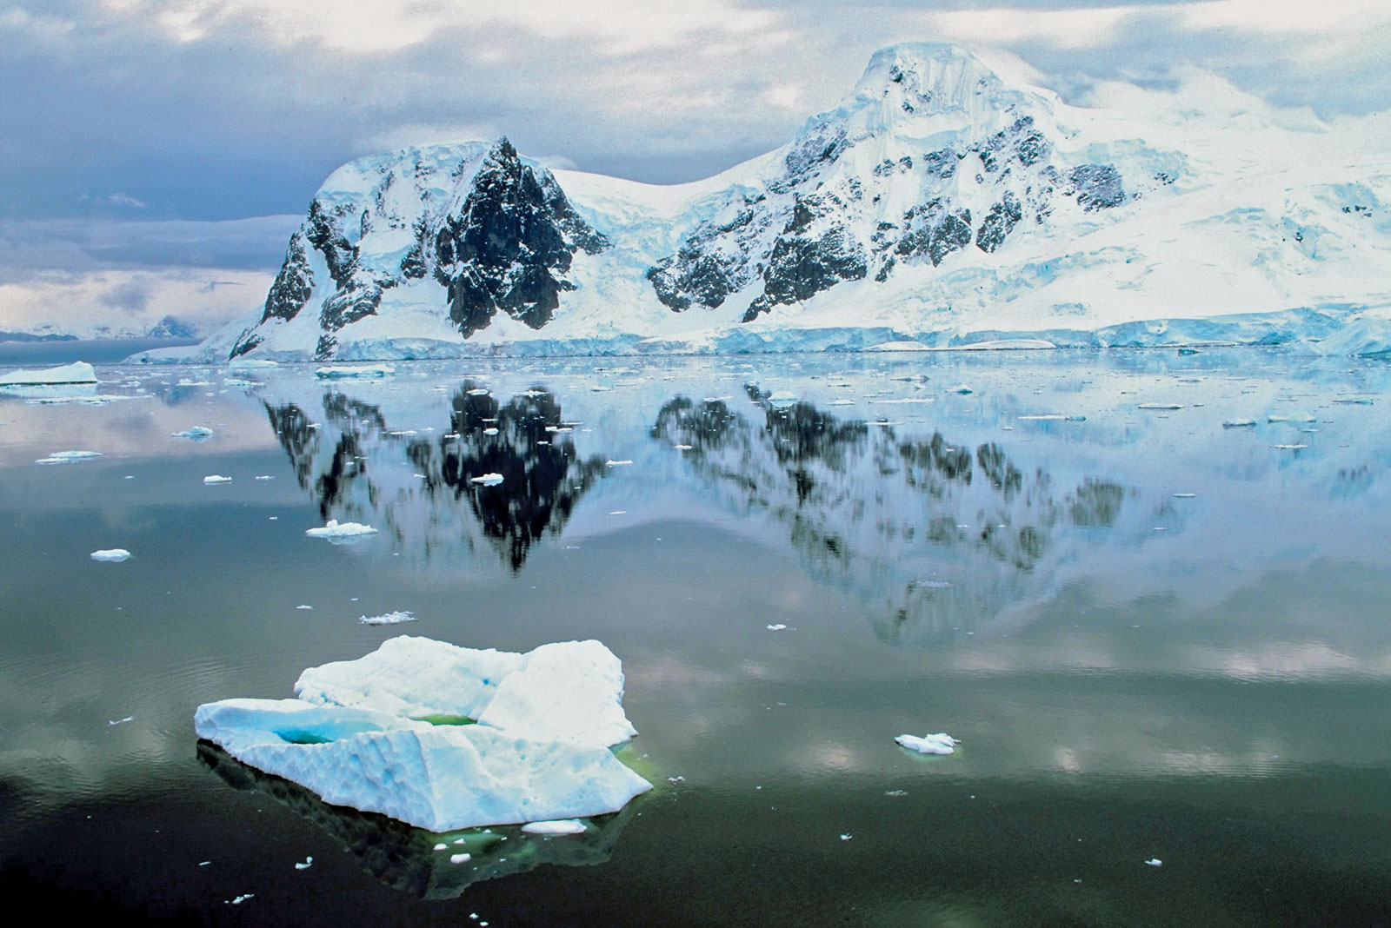[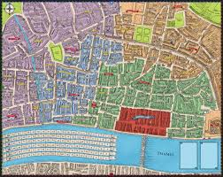](http://www.google.co.uk/url?sa=i&rct=j&q=great+fire+of+london&source=images&cd=&cad=rja&uact=8&docid=ZPoiHldvv2av7M&tbnid=WC4SR_AEiJQz-M:&ved=0CAUQjRw&url=http://www.medusagames.co.uk/greatfire.php&ei=nnqxU8_YAumx0QW9uICQBQ&bvm=bv.69837884,d.d2k&psig=AFQjCNFM3KHBxTc3bipn0ATaIGau-LSxyA&ust=1404226562434763)

**English**

[Our English](https://en.wikipedia.org/wiki/File:London_Bus_route_55_Buses,_Clapton_Pond.jpg) focus this half term is Frozen; which we will use for a range of writing outcomes. [We will be working on using our phonics to segment words for writing and structuring sentences with capital letters, finger gaps and full stops. We will also work on extending our sentences with the use of ‘and’ and begin to use question marks. Additionally, we will have daily ‘Read, Write Inc’ sessions to build on our phonics, reading and writing skills.](https://en.wikipedia.org/wiki/File:London_Bus_route_55_Buses,_Clapton_Pond.jpg)

**Maths**

[In maths, we will be building on our place value and addition and subtractions skills.](https://en.wikipedia.org/wiki/File:London_Bus_route_55_Buses,_Clapton_Pond.jpg)

**Music**

Music will be delivered through Charanga.

**Science**

In science, we will be naming animals and identifying their body parts. We will also be classifying animals into mammals, reptiles, amphibians, fish and birds.

**History and Geography**

We will be locating the continents, Equator, North Pole and South Pole. We will then look at Antarctica further and the expedition of Captain Robert Falcon Scott. Whilst doing this, we will ask questions and use a range of sources to gather information.

**DT and art**

We will be exploring the hot and cold colours and using cold colours to make polar art.

**R.E**

Our RE topic this half term will be ‘special people’. We will reflect on our own special people and explore special people in the church.

Cold Lands

Where are the Polar Regions and what are they like?

Year 1 Spring 1