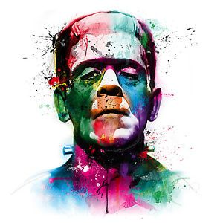
Topic
Maths:
In Maths this term we will continue to work on all 4 operations and arithmetic skills.
We will be using White Rose Hub to develop our reasoning and problem solving skills.
Ancient Islamic Civilisation.
We will be studying:
Ancient baghdad
House of wisdom
The 4 caliphs
In art we will explore Islamic art.
Year 6 – life & death

‘frankenstein’

English:
This half term we will be focusing on
the ‘Gothic Genre’.
We will be studying Mary Shelley’s
Frankenstein (ORT version). We will
be reading various gothic texts and
types such as poetry –
The Highway man and Lucy Gray

In our writing we will:
- Write setting descriptions
- Write character descriptions
and profiles
- Write a persuasive argument
In Spag, we will continue to focus on
year 5/6 spellings and

RE:
During the Spring Term we will
think about the ‘Epiphany’ and the
visit of the Three Wise Men. As
part of part of ‘Come and See’ we
will be exploring the theme of unity.
What does it mean to be united?
We will plan our own collective
worships based on this theme.

Science:
Evolution and inheritance
We will: recognise that living things produce offspring.
To identify how animals and plants adapt to an environment
To learn about fossil

