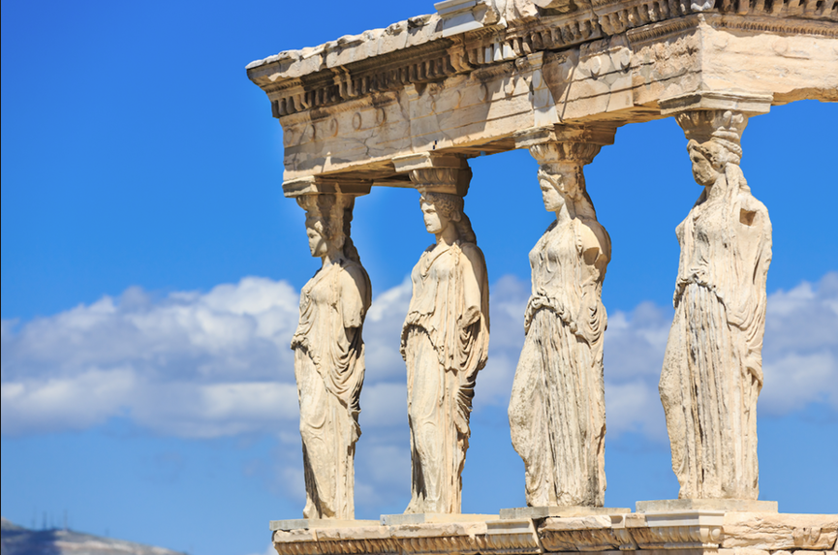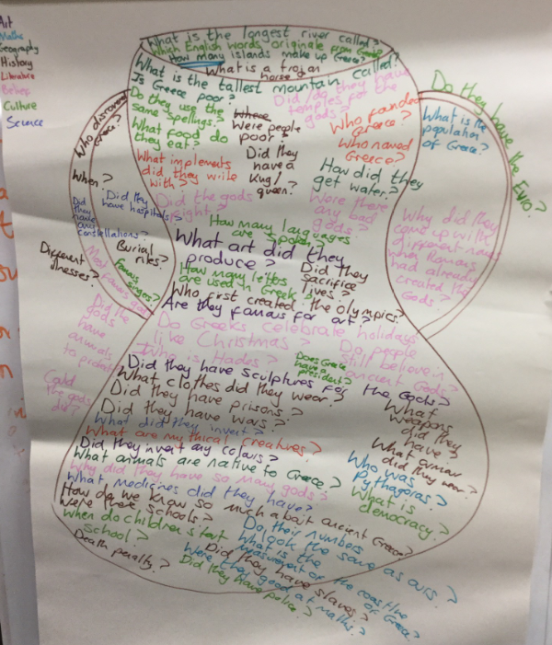

**Music**

We will be studying Jazz and using lots of our learning time to listen and appreciate different genres of music.

**MFL – French**

We will be starting to learn French with Miss Robson.

5T – Spring 1

**Do heroes have to be strong? Focus on the Ancient Greeks**.

**PE**

PE will be on Wednesdays and Fridays. The children will study dance and tag rugby.

**Geography**

We will be discovering the geography of Greece to create our own travel guide and budget holiday to Greece, planning routes using what we know about Greece from maps and choosing the best journeys. We will also be looking at why people choose to go to Greece on holiday and the effect of tourism on the area.

**RE**

**We will be learning about:**

Mission - Continuing Jesus’ mission in diocese (ecumenism)

Memorial sacrifice – Eucharist as the memorial of Jesus’ sacrifice.

Happy new year and welcome back to Year Five. This half term, our children will be exploring the key question, “Does a hero have to be strong?”. They will be exploring this question through the study of the Ancient Greeks. Already, the children have come up with interesting questions for our big picture (see photo). This topic focuses on the legacy that the Greeks left for today’s world and their influence on our lives.

PE has changed days this half term and is on a Wednesday and Friday. With the cold weather, it is advisable that your child has jogging bottoms for PE and brings a coat to school every day.

Miss Thomas, Mr Dakin and Mr Nash.

**Maths**

We will be continuing to understand how to multiply and divide bigger numbers and how to interpret remainders. After this, we will then be starting our journey into our largest topic, fractions, decimals and percentages, which will last until after Easter.

**English**

We will be focussing on Ancient Greek myths, creating our own after extensive work on the gods, mythical creatures and character descriptions. Our SPAG focus will be direct speech, relative clauses and subordinating conjunctions.

**Design Technology**

We will be designing, making and evaluating our own Greek feast. We will be learning about how to be hygienic when cooking.

**Art**

We will be looking at the history of the Ancient Greeks by studying Greek pottery. We will also look at Greek architecture and create our own Greek columns.

**Science**

We will be continuing our exploration of the properties of materials by experimenting with filtration, separation and evaporation.

**Computing**

The children will be creating animated GIFs, posters about e-safety and learning how to code an algorithm to create a game.

**History**

We will be discovering the origination of the Olympic Games and democracy. We will be finding out about Greek culture , including the Greek gods. We will also be finding out about how the Greeks influenced the world and the legacy they left for the modern world.