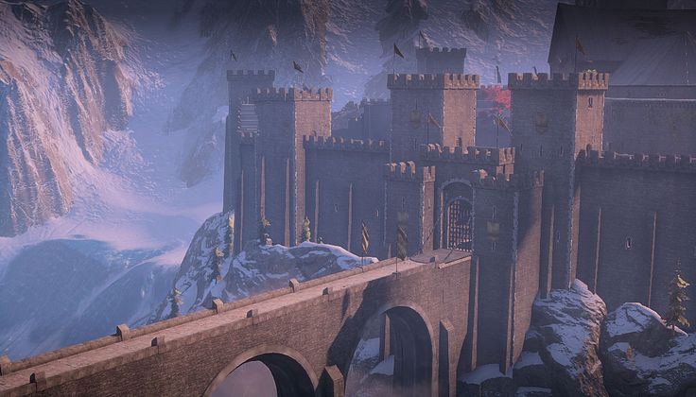 [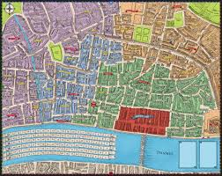](http://www.google.co.uk/url?sa=i&rct=j&q=great+fire+of+london&source=images&cd=&cad=rja&uact=8&docid=ZPoiHldvv2av7M&tbnid=WC4SR_AEiJQz-M:&ved=0CAUQjRw&url=http://www.medusagames.co.uk/greatfire.php&ei=nnqxU8_YAumx0QW9uICQBQ&bvm=bv.69837884,d.d2k&psig=AFQjCNFM3KHBxTc3bipn0ATaIGau-LSxyA&ust=1404226562434763)

**Castles and Dragons**

**Year 2**

**2019 - 2020**

**Spring 1**

**R.E.**

Our topic this half term is: ***Books and Thanksgiving***. During these topics we will learn to know and understand:

* The different books used at home and in school.
* The books used in Church on Sunday by the parish family.
* Different ways to say thank you.
* The Eucharist: the parish family thanks God for Jesus.

**Music**

Taught by Rochdale music service.

I Wanna Play In A Band is a rock song written especially for children. In this song you learn about singing and playing together in an ensemble.

As well as learning to sing, play, improvise and compose with this song, children will listen and appraise classic rock songs.

**Art and D&T**

We will be focusing on designing and creating our very own family coats of arms and also a shield. We will plan the creation of these items and then use a range of materials to make them.

We will be focusing on the history of WW1, designing and making our own peace symbols and making poppy biscuits. Then we will be focusing on our Wicked Weather topic; painting the seasonal trees/ wicked weather examples. Finally, we will take part in Christmas craft projects.

**Maths**

Along with daily Arithmetic sessions and TTRockstars, this half term we will be exploring other mathematical strands. We will become fluent and explore reasoning and problem solving activities. Some of the objectives that we will be covering include:

* **Multiplication & Division -** recalling multiplication and division facts for 2, 5 and 10 and use them to solve simple problems, demonstrating an understanding of commutativity as necessary.
* **Statistics –** make tally charts, draw and interpret pictograms and draw and interpret block diagrams.
* **Shape –** recognise 2D and 3D shapes, understand the properties of 2D and 3D shapes and understand lines of symmetry.

**English**

This half term, the key text focuses will be: Hector and the Big Bad Knight, Sir Charlie Stinky Socks and also castle non-fiction books. We will be focusing on informal letter writing, leaflet writing, recount writing and adventure story writing. To continue improving our writing, we will be using lots of Kagan techniques and having a daily grammar focus in our written work. This half term, our grammar focuses will be: past and present tense, subordination, exclamation marks, formation of nouns by compounding, formation of nouns using suffixes and use of progressive form of verbs. We will be showcasing lots of our work on the website and on twitter – keep a look out!

**Science**

In science this half term, we will be looking at habitats. We will learn what this word means and why different plants and animals need different habitats to survive. We will be looking at this on a local and a world scale. We will also be looking at how we know if something is alive by using the phrase, Mrs Gren.

**Computing**

During our computing lessons this half term, we will be focusing on our Information Technology and coding Skills. We will complete the following activities:

* Coding using algorithms.
* Book creator.

**History/Geography**

In our history lessons, we will be focusing on the monarchy and on Queen Elizabeth II. We will also be looking at the history of Skipton Castle ahead of our class trip there. We will also research the history of shield and coats of arms ahead of our art and D&T lessons.

In our Geography lessons, we will be looking at the location of Skipton castle and why its landscape was successful for the building of a castle.