Behaviour at St Mary’s

‘As the family of St. Mary’s, learning and growing in God’s love, joyfully, we pray, play and respect all, changing our world forever’

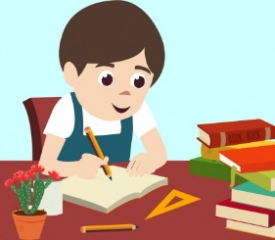
At St Mary’s we strive to follow the school rules and
follow the example of Jesus.
We should remember to always try our best and help
others.

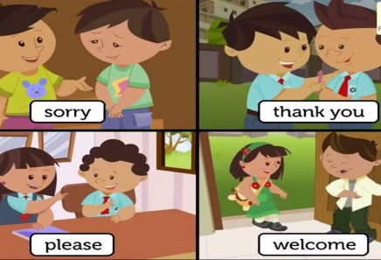
At St Mary’s we use our manners and treat our friends and adults with love and respect!

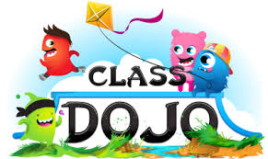
If we chose to do the right thing – we get rewarded with Dojos!!!
How can I get Dojos?
- Being kind
- Helping other
- Finishing work
- Trying my best

All the dojos are added together and at the end of a half term you can change your dojos into Mary’s Money and spend it at Mary’s Market!!!

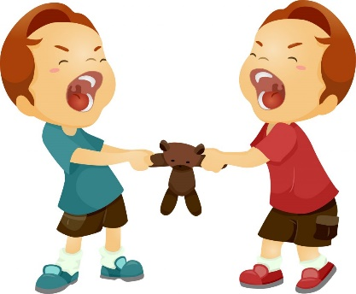
Sometimes we might not choose to do the right thing.
We might talk in class, answer somebody back
or call somebody names – what happens then?

SANCTIONS
Name on Board – Time out in class.

X – Sat on own in class.

XX – Sent to another class for pm or am following day.
XXX – sent to another class for full day - Letter home to parents.

XXXX – Sent to SLT – Parents to Meet Mrs Geddis.

XXXXX – Letter from Head Teacher. Further poor behaviour
means time out from school.

Remember – always try your best to do the right thing and make the right choices.

