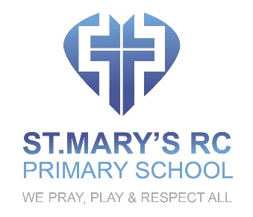

COMPUTING POLICY

OVERVIEW
                - At St. Mary’s, we will provide a high-quality computing education that equips pupils to use computational thinking and creativity to understand and change the world. Strong links will be made with mathematics, science, and design and technology, and provides insights into both natural and artificial systems. The core of computing will be computer science, in which pupils will be taught the principles of information and computation, how digital systems work, and how to put this knowledge to use through programming.

INTENT
                - Through our computing curriculum, we aim to give our pupils the life-skills that will enable them to use new technology in a socially responsible and safe way in order to move into the world with integrity and confidence. Given the ever growing use of technology in the 21st century workplace, we want our pupils to be well equipped for this stage of their lives. Through the rich, ambitious and inspiring computing curriculum which we offer, we want all of the children to become independent users of computing technologies, gaining confidence and enjoyment from each lesson. We want technology to be used in a cross-curricular capacity in order to support and enhance learning throughout the school. It is our aim that the children at St Mary’s will become digitally literate and competent users of technology. In addition, our computer science lessons will allow them to develop creativity, resilience and problem-solving skills which we believe are essential, transferrable life-skills.

IMPLEMENTATION
- Pupils will be taught to understand what algorithms are; how they are implemented as programs on digital devices; and that programs execute by following precise and unambiguous instructions
- Pupils should be taught to create and debug simple programs in KS1 and design, write and debug programs that accomplish specific goals, including controlling or simulating physical systems; solve problems by decomposing them into smaller parts
- Pupils will be taught to use logical reasoning to predict the behaviour of simple programs and in KS2 they will be taught how to explain how some simple algorithms work and to detect and correct errors in algorithms and programs
- Pupils will learn how to use technology purposefully to create, organise, store, manipulate and retrieve digital content
- Pupils will be taught how to recognise common uses of information technology beyond school understand computer networks including the internet; how they can provide multiple services, such as the world wide web; and the opportunities they offer for communication and collaboration
- They will learn how to use sequence, selection, and repetition in programs; work with variables and various forms of input and output
- They will be taught how to use search technologies effectively, appreciate how results are selected and ranked, and be discerning in evaluating digital content
- They will learn how to select, use and combine a variety of software (including internet services) on a range of digital devices to design and create a range of programs, systems and content that accomplish given goals, including collecting, analysing, evaluating and presenting data and information

IMPACT
                - By the end of each key stage, pupils are expected to know, apply and understand the matters, skills and processes specified in the relevant programme of study. Pupils will know how to use technology safely and respectfully, keeping personal information private; identify where to go for help and support when they have concerns about content or contact on the internet or other online technologies. Pupils will recognise acceptable/unacceptable behaviour; identify a range of ways to report concerns about content and contact.

