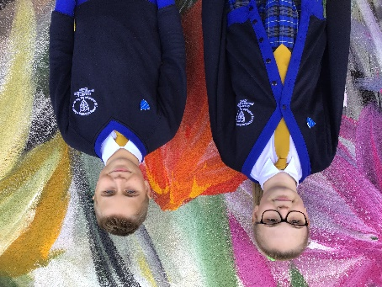
Pupil Voice Champions

This is an elected body of children from each class in KS2. They meet on a regular basis to put forward ideas relating to life at St. Mary’s for all pupils. Membership and minutes can be viewed on the school web site.

The School Council is a formal opportunity for children’s voices to be heard and to influence policy making decisions. The Members are given regular timed ‘slots’ in school to listen to the views of their class mates to help compile Agenda Items for the next Meeting. They have access to their own laptop computer for compiling Minutes and Agendas.
The Champions are responsible for working with other Pupil Voice groups, such as:

- The High 5 Helpers

The High 5 Helpers are a group of students from Year 4 and Year 5 who dedicate their time (at Lunchtimes) to help and support children who may have disagreements or feel lonely.
The High 5 Helpers work on the three sections of the Astro-turf and in the Outdoor Classroom (High 5 Hub) at Lunchtimes. They help children to think of resolutions to disagreements and offer friendly advice and support to those who need it.
The children in the High 5 Hub provide mindfulness activities such as colouring in.

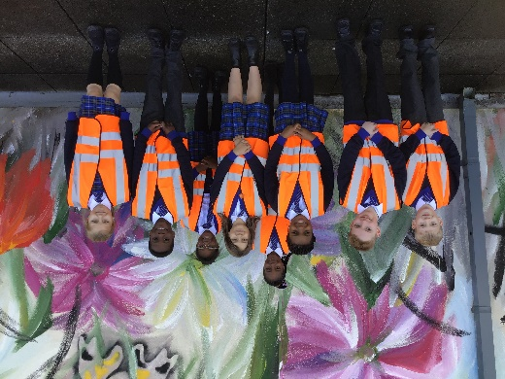

- Young Interpreters
The Young Interpreters are a group of children (some multilingual) who work to support children in our school family who may need help to socialise or communicate easily.
Young Interpreters undergo specific training to prepare for their role and are selected on the basis of different personal qualities they may have.

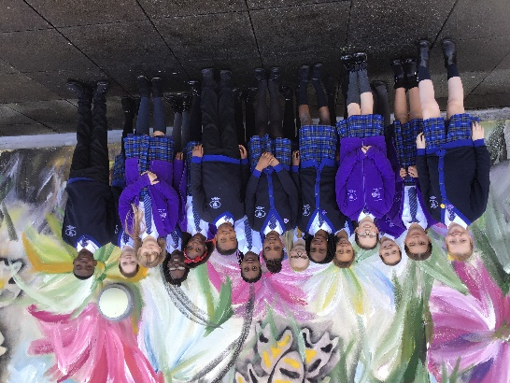

Rewards System

Class-based rewards

Individual - daily

The Class Dojo system is the main reward used for all pupils throughout the school.

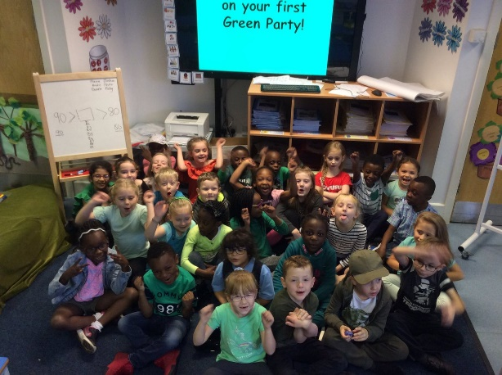

The Dojo points can be given to any child by any adult in school for any example of positive behaviour, i.e., academic, manners, etc.
The children can convert their dojo points half termly into Mary’s Money. They can then choose to spend this at Mary’s Market for an individual prize. The more dojo points – the bigger the prize.

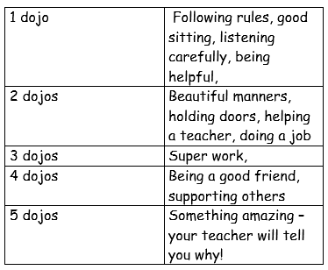

Individual – weekly

At the weekly Awards Assembly, one child from each class will receive a certificate for excellent work in a particular subject area. This is a reward for outstanding achievement in the given subject. The children also receive a prize based on the subject area – for example Geography Award – mini globe, Reading Award – book mark.
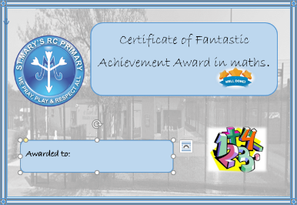
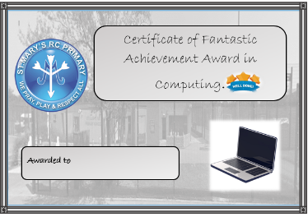
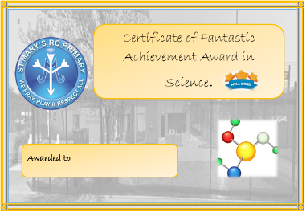

Each Friday a second child in each class will have a ‘surprise’ postcard sent home to inform their parents about their child’s social behaviour. This postcard will be signed by the Head Teacher and will not be given out in assembly.

Individual – Green Readers
Each week also children are given the opportunity to be entered into a class golden box prize draw if they have read at home at least five times. The children must have their books signed by a parent/carer and bring these into school. This is held weekly.

Individual Termly

Each Term, a child from each class will be awarded a 5W certificate. These are for an element of attitude or caring we expect from all children at St Marys, in line with the five W’s which underpin our Religious Education: - Word, Worship, Welcome, Witness and Welfare.

These awards are recorded by the class teacher.

Break Time – Hot Chocolate Monday

Each class chooses a pupil, who has had a particularly good week, to go to the library the following Monday for hot chocolate with one of the teachers. The children can enjoy a story or simply relax and enjoy the experience with friends.
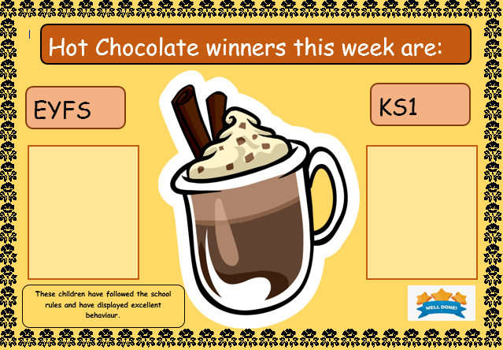

Whole class – weekly

When the whole class behave in a particularly good way, e.g., walking to and from the school hall quietly, listening to instructions, etc., they are awarded a marble in the class jar.

Ten marbles in the class jar (5 in Foundation Stage) equals another reward negotiated with the class.

Whole School – half termly.
Key stage 2 pupils are grouped into Houses. These are St. Bernadette, St. Maximilian, Mother Teresa and Father Damien.
When pupils transfer from KS1 to KS2 the Year 3 teachers will allocate each child to one of the four Houses.
Staff representatives are head of each house. Each half term, dojo points will be counted and the house with the most amount of points will have a cross key stage reward – decided by themselves and the staff representatives.

Consequence of rule breaking:

Each class has the child friendly behaviour policy in their classroom.

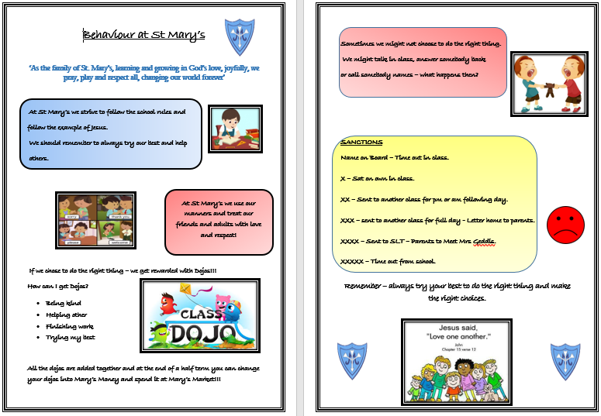

Each class has a behaviour ladder to reinforce behaviours and consequences. Children have the opportunity move up and down the ladder based on behaviour, this enables the children to have chances to change, reflect and act upon poor choices. Each day is a fresh start.

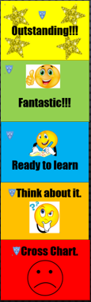

1 Name on board.

2 X Sit alone for short time - offer child opportunity to join in again - praise child at first opportunity.

3 XX Sit by self for rest of day - offer child opportunity to join class for the following day - praise at every opportunity.

4 XXX Send child to another class - arrange with other teacher in advance. Provide no work or activities. Inform parents of the action you are taking and the reasons for the action. This can be verbal. Parents also receive copy of ‘3 Cross Letter’.

5 XXXX Child sent to Mrs Geddis. If not available, send to Mr McGrail or other member of SLT. The child will be reminded about the consequences of his/her behaviour. Meeting arranged with parents regarding behaviour concerns and consequences of further misdemeanours.

6 XXXXX At this stage, Mrs Geddis will inform the child’s parents by letter about behaviour concerns. The parents will be informed that a further misdemeanour will result in either:

Exclusion during Dinner breaks for a five-day period.

Exclusion from school over a five day period.
An assurance from the parents that the school’s actions will be supported and a warning that the above sanctions will be brought into force if the behaviour continues.

The seriousness of the behaviour will decide which sanction is used. The decision regarding which sanction to use will be discussed with the class teacher before the parental interview.

Notes will be kept on all the above so that dates/events, etc., can be included in letters to the parents. A copy of this letter will be given to the class teacher for the child’s file. If the child is on the SEN List for Behaviour, the school SENCO will also be involved.

Crosses are kept on the board for two weeks in Year R. From Year 1 upward the crosses are kept on the board for a half term. When they are removed it should be explained to the child that this is an example of forgiveness and reconciliation.

When children are excluded for a fixed period the school will provide work to be completed at home. The work must be returned by the parent daily or as agreed with the class teacher.

During lunchtime the staff on duty record incidents of unacceptable behaviour.

The Head Teacher investigates these incidents every Friday Afternoon or at regular intervals.

