DESIGN A KIT COMPETITION
https://dreambigsports.co.uk/blog/2020/4/2/dream-big-sports-and-hope-amp-glory-sportswear-launch-thebigkitcomp
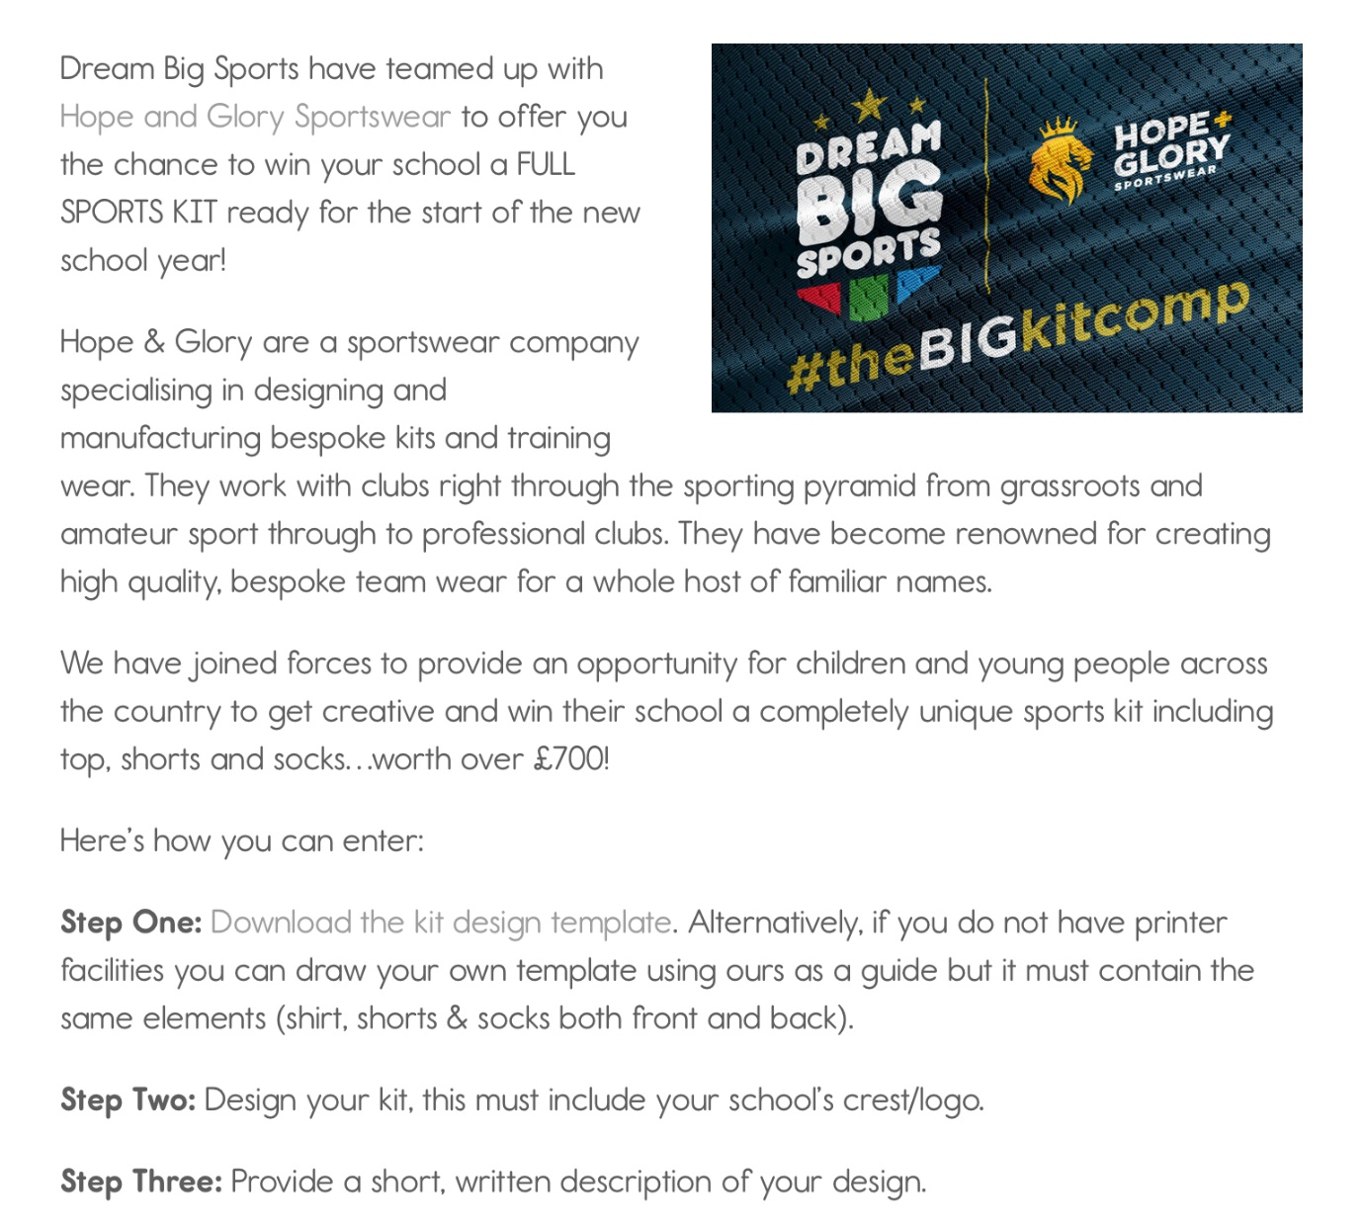
Step 4: Send them to Mr Feighan via Twitter (@stmrysrcmidd) Class Dojo (MrFeighan) or Email TFeighan@stmarysrcmidd.rochdale.sch.uk who will award a prize for best design within our school.
As well as send to info@dreambigsports.co.uk
Email in by Monday 20th April, and must include the following
Full Name
Age
School Name: St Mary’s RC Primary,
School Address: Wood Street, Middleton, M24 5GL
Parent / Guardian Name
Parent / Guardian Contact Number

