



Raise your hand (virtual!) if you want to say anything.





Set up your device in a well-lit, comfortable space, but not a bedroom if possible.



Speak in a normal voice, always using kind and friendly words.



Remember our school rules – they are still in place.





Where possible, backgrounds should be blank or blurred out. Don’t have any photos or personal information in view.

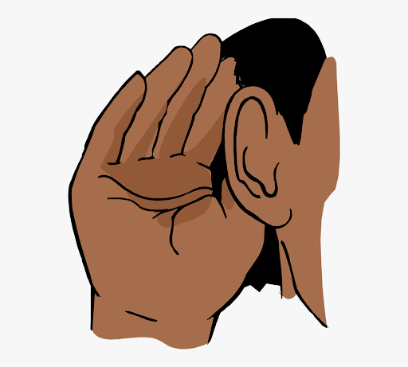

Listen carefully to the teacher and other pupils.



Enjoy yourselves! Don’t forget to wave when you join!

Pictures or recordings of the zoom call are NOT allowed.



Join the Zoom call with your video and microphone switched on.



Ensure you are appropriately dressed at all times.



Be on time.