EDUCATIONAL VISITS POLICY
OVERVIEW
St. Mary’s sees safe, enjoyable and relevant educational visits as an important strategy for extending the curriculum, and enhancing teaching and learning, so they are encouraged. The care and safety of pupils will be given the highest priority during such visits and all staff will ensure that the visit is well prepared, well planned, risk assessed and well supervised. All relevant school policies will apply off site as they do onsite and staff will be responsible for ensuring that the high standards set out in those policies are met during the visit. The DfE and LA Guidance and Procedures for Educational Visits and Health & Safety of Pupils on Educational Visits (a good practice guide) DfE, will under-pin all aspects of preparation and implementation of school visits
INTENT
- To ensure that the children experience a wide variety of educational visits to extend and enrich their education.
- To provide links between the world beyond school and the classroom and to make learning more effective by using visits to enrich the curriculum.
- To provide first-hand experience and to broaden learners horizons by taking learning out into the wider world beyond school in a safe manner.
- To meet National Curriculum requirements for field studies in Science, Geography, History and PE.
- To promote self-confidence and independent learning through a programme of visits which are carefully planned to match pupils’ needs.
- To ensure that all may participate in visits in line with our Single Equality Policy.
IMPLEMENTATION
- The headteacher’s and EVC’s permission must be sought well in advance of any proposed visit and once all the preparations have been made the headteacher must approve the visit before it take place. Staff complete visit form (EVOLVE) and appropriate ESRA, EV7 and EV8 and submit to head/EVC electronically.
- The health, safety and care of pupils must be paramount in the planning and organisation of the visit and it must meet the standards set out in all other relevant school policies including Behaviour Policy, Critical Incident Policy, First Aid Policy, Health and Safety Policy, Intimate Care Policy, Medical care Policy, Medicine Policy and Missing Child Policy.
- Members of leading visits must be appropriately qualified and the leader must ensure beforehand that those leading and supervising activities have the appropriate specialist qualifications for those activities and that the qualifications are current and up to date, including appropriate medical training.
- To ensure that any child with known severe allergic reactions (anaphylaxis) is recognised by staff and where they have an EpiPen, it is available and that staff know how to use it in an emergency. ( see annex)
- Thorough preparation for a class visit will include a pre-visit by teacher(s) and a thorough risk assessment in line with the Risk Assessment Policy.
- Most class visits will take place within the school day and must be planned well in advance.
- Children will be organised into groups (taking into account minimum adults: pupil ratios), which are best suited to the type of work to be carried out and the nature of the visit.
- Well in advance of the visit children will take a letter home which contains details of the place, date, times of departure and return, the cost, a suggested amount of spending money and any special requirements (eg, appropriate forms of dress, packed lunches, drinks provision etc).
- The leader will ensure that adequate first-aid provision is available in line with the school’s First Aid Policy.
- The school will not exclude anyone from educational visits on financial grounds or because of of special needs or disability.
- Detailed information about the purpose of the visit, the activities to be undertaken, the time, and place of the visit including the method of transport and arrangements for meeting children afterwards will be notified to parents.
- The leader will ensure that details of the emergency contact numbers, school contact numbers and parent contact numbers for pupils are available to all the staff responsible for the supervision and care of the pupils.
- A consent form giving full details of the visit (see 7 above) must be signed by the parent/guardian before the visit and this must include the parent/guardian’s emergency contact number.
- The school will appoint a senior member of staff to be Educational Visits Co-ordinator (EVC).
- The EVC will check the arrangements for every visit before recommending the visit for approval by the headteacher.
- The EVC will be responsible for staff training and ensure that all staff leading and participating in visits understand and follow this policy.
IMPACT
The purpose of all educational visits is to enhance children’s learning experiences, to give opportunities for sensitive and purposeful social interaction with peers and other adults in a safe and supportive framework. This policy will ensure that visits are carefully planned and prepared and well supervised so that children benefit from the rich opportunities that such visits offer them.

Anaphylaxis
Anaphylaxis is a serious life-threatening type of allergic reaction. It usually develops suddenly and gets worse very quickly.
The symptoms include:
- feeling lightheaded or faint
- breathing difficulties – such as fast, shallow breathing
- wheezing
- a fast heartbeat
- clammy skin
- confusion and anxiety
- collapsing or losing consciousness
There may also be other allergy symptoms, including an itchy, raised rash (hives), feeling or being sick, swelling (angioedema), or stomach pain.

What to do if someone has anaphylaxis
Anaphylaxis is a medical emergency. It can be very serious if not treated quickly.
If someone has symptoms of anaphylaxis, you should:
- call 999 for an ambulance immediately – mention that you think the person has anaphylaxis
- remove any trigger if possible – for example, carefully remove any wasp or bee sting stuck in the skin
- lie the person down flat – unless they're unconscious, pregnant or having breathing difficulties
- use an adrenaline auto-injector if the person has one – but make sure you know how to use it correctly first
- give another injection after 5-15 minutes if the symptoms don't improve and a second auto-injector is available
- Keep the child lying down or seated and have someone stay with them until they have been assessed by a paramedic.
- Unconscious patients should be placed in the recovery position

Guide to Using An EpiPen®
- There is no need to remove clothing to use an EpiPen®, but make sure the orange end will not hit buckles, zips, buttons or thick seams on clothes.
- To remove EpiPen® from the carry case. Flip open the lid on the carry case. Tip the carry case and slide the EpiPen® out of the carry case.
- Lie the child down with their legs slightly elevated to keep their blood flowing or sit them up if breathing is difficult.
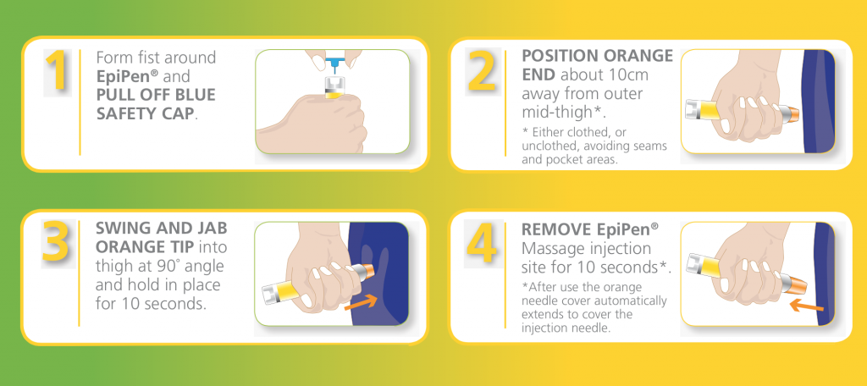
Each EpiPen® can only be used once. If symptoms don’t improve, you can administer a second EpiPen® after 5-15 minutes.
