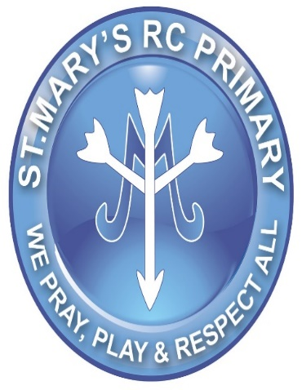 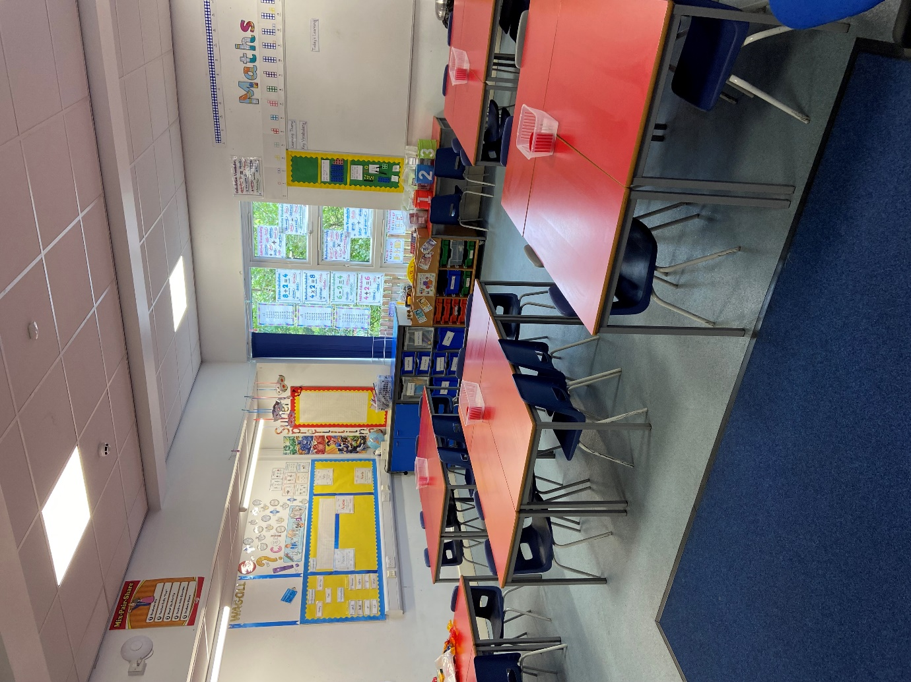

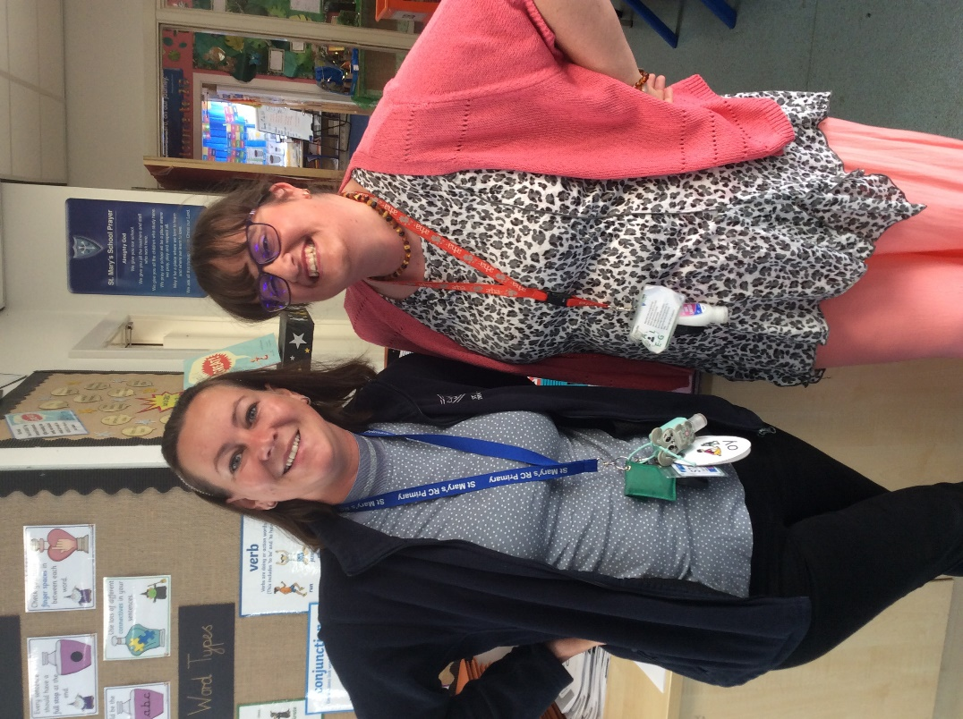

Welcome to Class 3R …..

**All About Me**

 I am really looking forward to teaching you this year. This is my 3rd year at St Mary’s and I am really looking forward to teaching you again. We had lots of fun in Year One but did not get to finish the year together. I am really looking forward to teaching you for the whole year. I am so excited about teaching you French, as well as all the other wonderful subjects we have.

**My favourite things:**

Spending time with my family.

Going for walks.

Visiting new places.

Eating out

Going to the cinema

Hello, my name is Miss Robson and Miss Howard will be our Teaching Assistant. We are really looking forward to teaching you this year.

Our class will be called 2R and our classroom is at the top of the staircase on the right.

**Photo of the classroom**

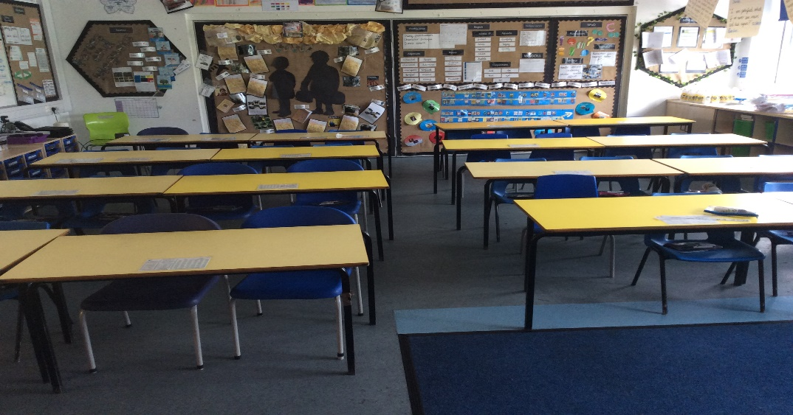

**What will we be learning:**

This half term, we will be learning about the Stone Age all the way up to the Iron Age. We will be using lots of timelines and artefacts to help our learning. Hopefully by October half term, we will all be experts in the pre-historic era.