 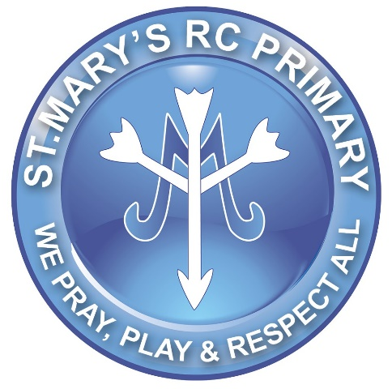

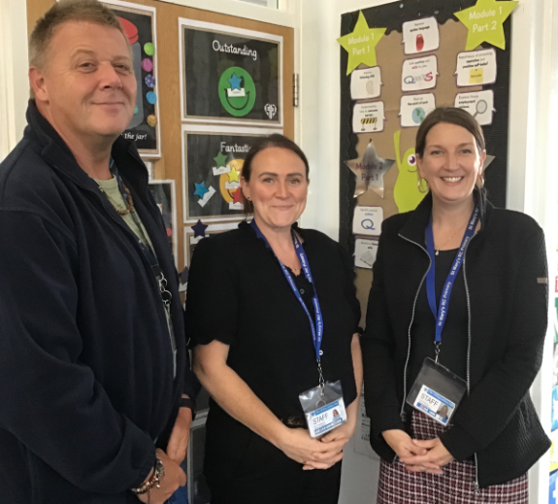

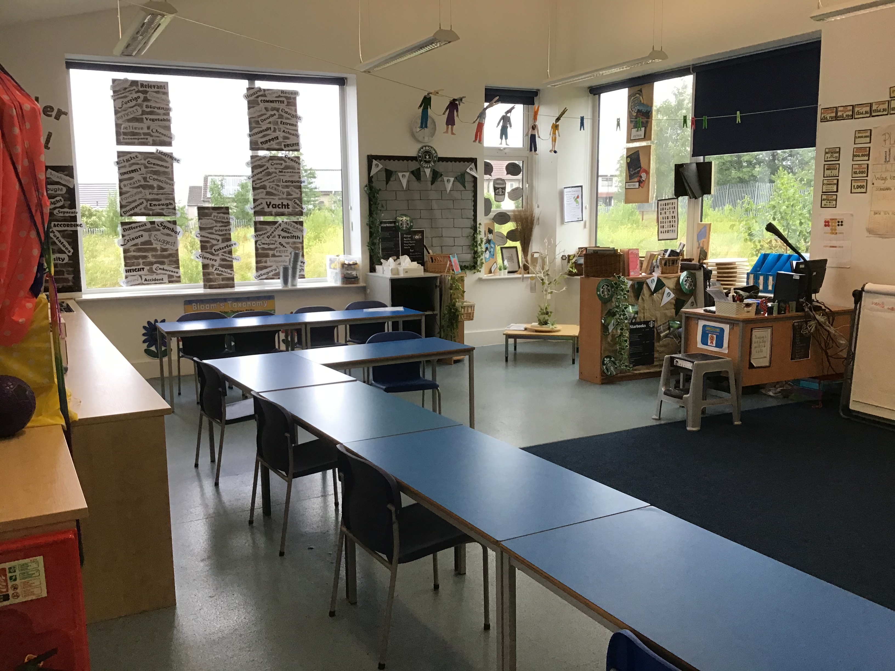

**All About Me**

I’m sure that most of you know me as I have already taught many of you before. I have been at St. Mary’s for many years and I have worked in every year group! I really enjoy teaching the exciting topics in year 6! When I am away from school I am a mum to my two girls who are 7 and 5 years old (they keep me very busy!). Much of my time at home is spent on long walks or reading a good book. I love to cook (although I am not very good at it). My favourite colour is blue and I support Manchester City.

**What will we be learning:**

* All about ourselves & our bodies
* Understanding the wider world
* Evolution including fossils
* WW1
* Gothic stories including Frankenstein
* Tudors

**My favourite things:**

* Writing poems
* Listening to music
* Reading
* Having fun!
* Drinking coffee.
* Chocolate!!!

Welcome to Class 6B …..

Hello, my name is Mrs Bonnar and I am really looking forward to teaching you this year. Mrs Hodkinson and Nash will be in our class too!

Our class will be called 6B and our classroom is at the top of the Year 2 stairs, just off the roof terrace.