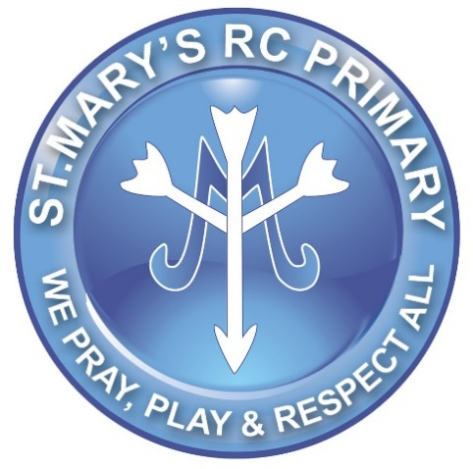Free Story Book Clipart, Download Free Clip Art, Free Clip Art on ...

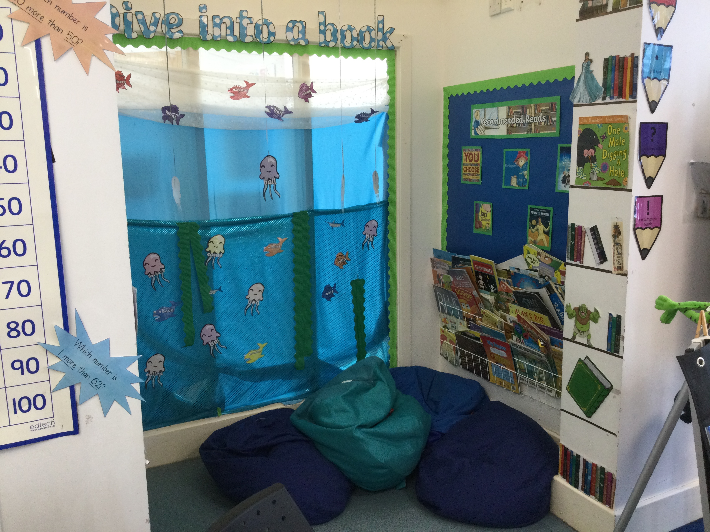

**All About Me**

**I have been a Teacher at St.Mary’s for seven years now. I love to go on long walks with my dog. He is a chocolate beagle called Winston!**

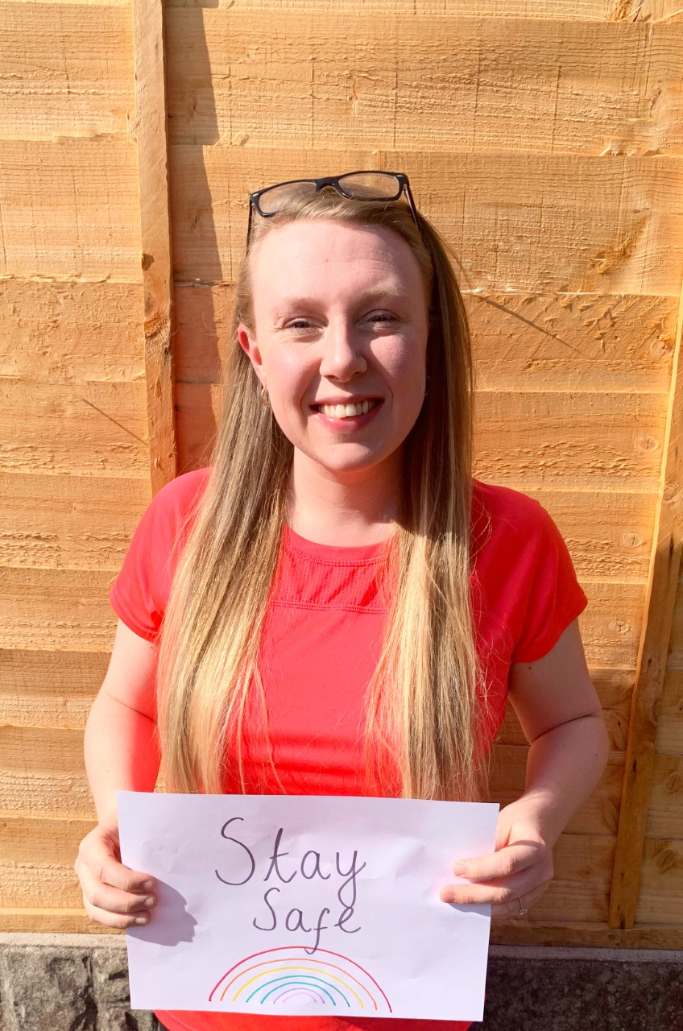

Welcome to Class 1L …..

Have a look at our classroom …

**Hello! My name is Mrs Lewis and I will be your Teacher this year. Mrs Bowden will also be working in our classroom. We are looking forward to a great year!**

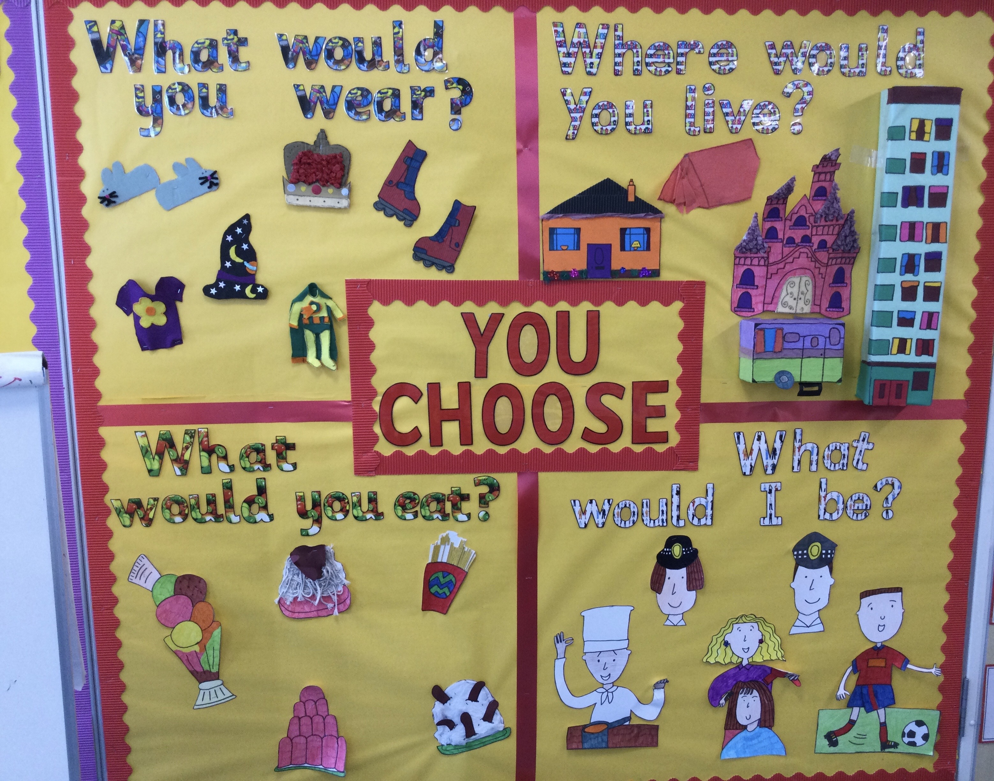

**What will we be learning:**

We’ve got very exciting things planned for next year and our first topic will be ‘this is me and my town’. We will be learning all about our local area.

**My favourite things:**

* **The colour orange.**
* **Ice cream.**
* **Going on holiday.**
* **Reading.**
* **Snowy days.**