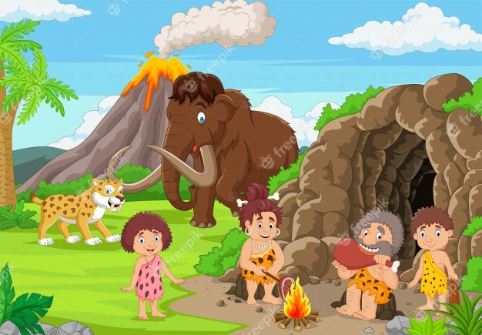

**FRENCH**

This year the children will be introduced to French. We will learn how to count to 6, basic greetings, a few colours, and some classroom phrases

**PE**

Mr Senior will teach the children PE on Tuesday and Friday. They will be starting the term with a focus on gymnastics. Please ensure PE kit is in school and fully labelled.

**COMPUTING**

During these lessons, the children will be discussing the importance of E-Safety and also look at coding.

**RE**

This half term we will be looking at the topic ‘homes’ and using bible references to help us to understand how we can create loving homes in different places e.g. at home, in school, in our Parish, in after school clubs etc.

**ART/ D+T/ MUSIC**

Mr Doherty will teach the children music this half term. In art, we will be looking at prehistoric art, to link in with our topic. This will mean we will complete our own cave paintings. We have also done some class art work based on the ‘Little People, Big Dream’ books.

**GEOGRAPHY**

This half term we will use maps to identify where places of interest are from this era. Our next half term will be a term with more of a geography focus.

**HISTORY**

Our topic this half term is very history centred. Therefore, we will be looking at the different eras of pre-historic times and becoming historians to decipher what happened during these times. We will look at what the people ate, did, how they spent time etc. and will use timelines to support our learning.

**MATHS**

This half term we will be starting our learning with place value. We will recap on some of the place value we learnt in Year 2 and developing our knowledge to work with numbers to 1000. After this, we will be working on addition and subtraction to 3 digits.

**SCIENCE**

Mrs Greenwood teaches science to the children each Tuesday. This half term they are focussing on the topic: Animals, including Humans. They will look at the body, focussing on bones and muscles as well as how we can keep our bodies and animal bodies healthy.

**ENGLISH**

This half term we will be looking at journal writing, setting descriptions, instruction writing and non-chronological reports. The children will be supported through this by reading high quality texts and by having grammar and handwriting lessons.

**3R Autumn Term 1**

**From Stone to Steel – How did England Change?**