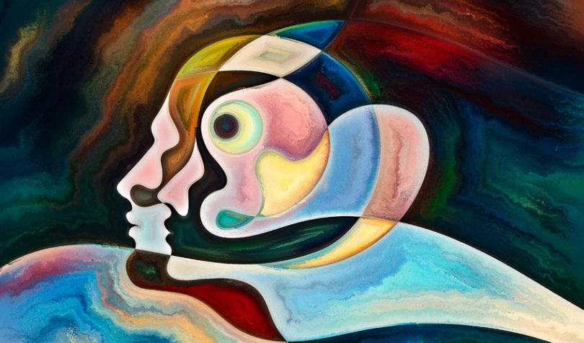

**English**

Our work this half term is based around the theme of identity and editing and improving our own work. We will recap on using thesauri and dictionaries as well as focussing on our Year 5 and 6 spellings. We will be writing character profiles, character descriptions, letters and diary entries based on texts we read which will include The Day the Crayons Quit, Can I build another me and videos clips from Indie Out, Little Freak and Wonder. We will also use drama as a vehicle for learning and integrating dialogue into our writing.

**Mathematics**

We will start our year off by looking at the place value, addition and subtraction, multiplication and division of numbers up to five digits in length. We will then use this knowledge to reason and solve problems. Following this, we will be looking at statistics including reading bar graphs, line graphs and pie charts and solving problems using these. We will also be looking at statistics related to our topic including time zones.

**Science**

This term, we will be studying “Evolution and Inheritance”. The children will be looking at how living things have changed over time and that fossils provide information about living things that inhabited the Earth years ago.

**PE**

PE will be taught by Mr Senior on Mondays and Wednesdays. Please can all PE kit and coats be clearly labelled with names. The children will be developing their gymnastic and tennis skills.

**History/Geography**

We will use geographical skills to read and create maps looking at flags and capital cities. We will link our lessons to our own identities and family heritage.

**RE / SMSC**

We will be completing our topic ‘Loving’ and ‘Vocations’ this half term thinking about unconditional love and how we are disciples of Jesus. We will also begin our RSE topic Life to the Full.

**Music**

This term, Y6 are studying the genres of pop and Motown, looking specifically at "Happy" by Pharell Williams.  They will listen and appraise songs which take influence from this genre and will continue to work on their musicianship, composition and notation skills, building on their Y5 learning.

**Computing**

In Computing lessons, we will be learning the value of e-safety, how to use a spreadsheet and internet searching skills.

**Art & Design Technology**

I can explore the use of emotion in art. I can create graffiti art. I can critically analyse a well-known piece of art work.

Linked to our topic ‘Identity’ we will be embarking on our raising aspirations topic and opening up the world of work. It shows us what careers are out there and the skills we’ll need to leave a positive footprint wherever we go in life. We will work on building our self-belief, our resilience, recognising our qualities and how they could be used in the workplace.

**6B**

**Identity – who are you?**