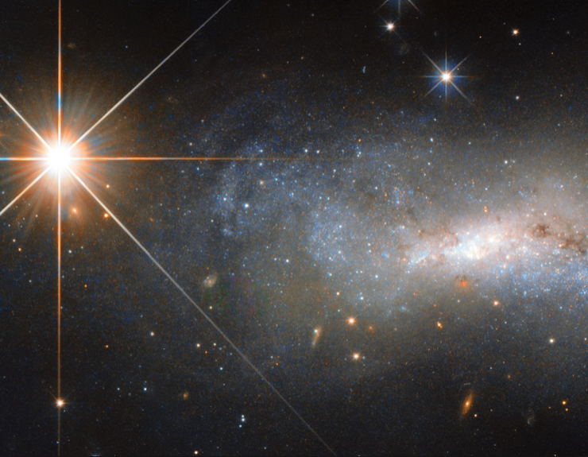

**English**

Our work this half term is based around editing and improving our own work. We will recap on using thesauri and dictionaries as well as using the sound “/shun” with different spellings. We will be writing newspaper reports, speeches, letters, diary entries and character descriptions based on texts we read which will include space poems, Mungo and the Spiders from Space and The Jamie Drake Equation.

**Mathematics**

We will start our year off by looking at the place value, addition and subtraction of numbers up to five digits in length. We will then use this knowledge to reason and solve problems. Following this, we will be looking at statistics including reading bar graphs, line graphs and pie charts and solving problems using these. We will also be looking at statistics related to our topic including time zones.

**Science**

This term, we will be studying “Earth and Space”. Most of our topic will be connected to our learning in science. We will study how the planets move; we will investigate the effect of speed and size of meteors on the creation of craters and we will discover how rockets make it into orbit. We will also be accessing scientific evidence to prove / disprove theories about the movement of the planets.

**PE**

PE will be taught by Mr Senior on Tuesdays and Wednesdays. Please can all PE kit and coats be labelled with names.

**RE / SMSC**

We will be having various debates this half term to challenge our understanding of how Jesus wanted us to live our lives. We will also be studying the qualities God wants us to have to be part of his family and the life choices people make, in particular vocations to the priesthood.

**Geography**

We will use geographical skills to read and create maps of the solar system, and use what we know about our own planet to work out time zones across Earth. We will also look at comparing the geography of the Moon to the geography of the Earth.

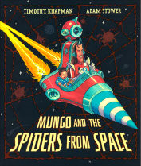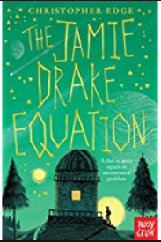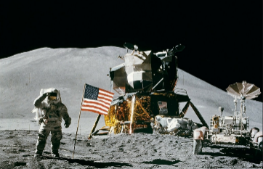

**History**

We will hone our historical enquiry skills by looking at whether the 1969 Moon landing was real; what caused the Challenger disaster and the events that led to the Space Race. We will do this by accessing primary and secondary sources and discussing their value.

**Computing**

In Computing lessons, we will be learning the value of e-safety, how to use a spreadsheet and internet searching skills.

**5H Autumn 1**

**Is Anybody Out There?**

**Art & Design Technology**

In Art, the children will be studying different skills of art and design, such as 3D, shading, collage and enlargement.

In D&T, the children will design, make and evaluate their own bottle rocket using recycled materials.

**Music**

We will be studying rock as a genre of music, concentrating around Livin’ on a Prayer. We will also be looking at space-themed songs such as 2001-A Space Oddity by David Bowie and Calling Occupants of Interplanetary Craft to explore how to listen and appreciate a piece of music. We will also listen to the Planets Suite in connection to our art work.