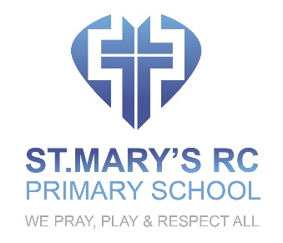

ART AND DESIGN POLICY

OVERVIEW
At St. Mary’s School, art and design will be subjects used to enable pupils develop knowledge, skills and understanding to communicate their thoughts and ideas across the curriculum. All pupils will be taught art, craft and design to engage, inspire and challenge them. Their developing knowledge, skills and understanding will quip them to experiment, invent and create their own works of art, craft and design. As pupils become artists and designers, they will be taught to think critically and develop a more rigorous understanding of art and design. Through cross-curricular work pupils will learn that art and design both reflect and shape our history, and contribute to the culture, creativity and wealth of our nation.

INTENT
- To use the programmes of study of the National Curriculum for art to underpin teaching and learning:
- To enable pupils to produce creative work, exploring their ideas and recording their experiences
- To help pupils become proficient in drawing, painting, sculpture and other art, craft and design techniques
- To teach pupils how to evaluate and analyse creative works using the language of art, craft and design
- To ensure that pupils know about great artists, craft makers and designers, and understand the historical and cultural development of their art forms.
- To use the wider subjects of the curriculum e.g. English, mathematics, geography, history, science to provide stimulus and starting points for art and design.

IMPLEMENTATION
- Pupils will be taught to use a range of materials creatively to design and make products
- Children will learn how to use drawing, painting and sculpture to develop and share their ideas, experiences and imagination
- Pupils will be taught how to develop a wide range of art and design techniques in using colour, pattern, texture, line, shape, form and space
- Pupils will be taught to develop their techniques, including their control and their use of materials, with creativity, experimentation and an increasing awareness of different kinds of art, craft and design.
- Pupils will be enabled to create sketch books to record their observations and use them to review and revisit ideas
- All children will be encouraged and shown how to improve their mastery of art and design techniques, including drawing, painting and sculpture with a range of materials [for example, pencil, charcoal, paint, clay]
- All will learn about the work of a range of artists, craft makers and designers, describing the differences and similarities between different practices and disciplines, and making links to their own work

IMPACT
During their time at St. Mary’s, children will benefit from a rich broad and balanced programme of art and design. They will experience and experiment with a wide range of materials as they explore art and design to grow and flourish as artists and designers. They will build a growing awareness of the art and design which runs through their own history, culture and other cultures as they are introduced to the world of artists and works of art. They will learn about sculptors, designers and architects and they will be taken to galleries, exhibitions and places rich in architectural heritage to broaden their horizons and to appreciate great works of art.

Revised and adopted by the Governing Body

Date 1 September 2021
Review Date 1 September 2024

