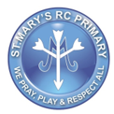

ST MARY’S RC
PRIMARY SCHOOL

Asset Management & Disposal Policy

1 May 2021

Prepared by Diane Lyons
Date 1 May 2021
To Be Reviewed 1 May 2024

- Asset & Disposal Register
School purchases a wide variety of items of furniture, equipment, plant etc. It is essential, for the proper recording of these assets. In the event of a fire, theft or other such event, reference can then be made to the register which will aid insurance claims.
A full and accurate register showing the acquisition, location and eventual disposal of all items of furniture, equipment etc. The register must be updated continuously (i.e. as and when additions and disposals take place).
Regular checks will be carried out on an annual basis to ensure the existence and accurate recording of items on the register. The inventory record should be signed and dated to evidence this check.

- Guidelines on Definition of Register Items
The register records all items such as furniture, fittings, equipment, plant/machinery and computer hardware and software purchased by school.
Items not purchased by school, e.g. leased, rented, donated, are also to be recorded on the register and details of the source noted within the Comments field.
Items from the categories above only need to be listed if they are portable and greater than £100 in value.
Desks, chairs and filing cabinets associated in and around a work station need not be listed.
Electrical and non-electrical items should be listed on the same register.
School have an electronic Asset and Disposal Register located at P:\Office\Asset Register
New items will be added to the register on receipt of the item. The items will be identified by the Purchase Order and Invoice recorded on Pastel. The Office staff will ensure that the register is updated.
Any items to be disposed off will be noted on the register at the time of the disposal, entering the relevant information onto the worksheet.

- Security
Access to valuable equipment is to be closely controlled and its use restricted to authorised users only. Where practical, attractive items should be kept locked away when not in use/and overnight and keys should only be accessible to authorised staff.
All reasonable steps are to be taken to maximise protection of equipment. This should include all attractive and portable items, such as computers, cameras etc.

- Safes
All safe keys must be removed from the premises overnight, otherwise the insurance is invalidated.
The details of all safes are required to be notified direct to the Insurance Section. A copy of the form can be found at Appendix 2 of this document.

- Annual Physical Check of Items on the Register
A physical check will be undertaken on an annual basis of all items on the register. This will be carried out in collaboration with all staff members. The record should be signed and dated to evidence this check.
This check is only to confirm the details of the inventory items ie. that it is still in use, the location is still correct etc. It is not to check any electrical supply to the equipment and can therefore be carried out by staff without specialist knowledge.
Any discrepancies should be investigated and reported to the Headteacher/Deputy Headteacher.

- Register Checks by Auditors
On any visit to an establishment, Internal Audit staff may request a copy of the register records and then carry out spot checks of equipment, machinery etc held at the establishment to ensure the completeness, accuracy and continuous updating of the records. (External audit may also carry out such checks).

- Removal of Equipment from Premises
Items of equipment should not be removed from the premises without proper authority. When a piece of equipment is required to be taken off the premises, this should be appropriately recorded onto the Asset and Disposal Register, including the date of removal and the name of the person removing the item. The Register will then be updated when the item is returned.
All items which are sent away or collected from the establishment for repair or maintenance are also be recorded in this log record.

- Disposal of Equipment
Obsolete equipment not only takes up space but potentially incurs on going maintenance costs. The school should therefore dispose of such equipment in line with the processes set out in this policy.

Items can be disposed if they are :-
- Not capable of running required operational software systems or being upgraded to do so;
- No longer required, due to changed procedures, functions or usage patterns;
- Beyond repair.

Assets identified for disposal can be disposed of using the following acceptable methods:-
- Sale of assets
- Donation of assets to a school or community service organisation
- Destroy / Recycle assets
- Donation or Selling Items to Staff
Choice of the most appropriate disposal option will be influenced by the age and functionality of the equipment for disposal and by market value.
- The sale of assets involves assigning a minimum price to the item and marketing the items for sale. Assets should be advertised as ‘sold as seen’ with no guarantee of lifespan given.

The minimum price should at least cover the costs connected to the disposal, for example those related to clearing data from PC’s or laptops. Appropriate documentary evidence needs to be retained to allow income to be accounted for to the point of banking (receipts, paying in slips). All items should be in a good and safe condition. Electrical goods should only be sold if the portable appliance test (PAT) is in date. If when originally purchased the asset was subject to VAT then VAT must be charged on the agreed sale price and schools should indicate this as vatable income when paid into the main school budget.

Checklist for Disposal of Assets
- Seek necessary authorisation i.e. Headteacher / Governing Body
- Remove the items from any outstanding maintenance arrangements
- Retain appropriate records
- Update the school inventory records
- Ensure items are in a good and safe condition
- Ensure PAT tests are in date for electrical appliances

- The school may authorise the donation of equipment to another organisation or school.

- Destroy / Recycle asset, items with no market value and no use to any other organisation or person may be destroyed in an appropriate and safe manner. Items must be destroyed or recycled in accordance with legislation.

Items with no market value and no use to any other organisation or person may be destroyed in an appropriate and safe manner. Items must be destroyed or recycled in accordance with legislation. Advice on how to destroy or recycle assets can be obtained from Operational Services.

It is essential to ensure that any computer and laptop hard drive / memory / data store is professionally cleared of such data prior to disposal. This is to ensure that the school adheres to data protection legislation and minimises the risk that sensitive information is exposed to unauthorised individuals.

School also have contact with Asset-Remarketing https://www.asset-remarketing.co.uk/ who provide an IT disposal/recycle asset services.

- Donation or Selling Items to Staff, when offering items to staff, school must follow the Council’s Code of Conduct which lays down guidelines on how schools and individual members of staff should avoid any impropriety or any suspicion of improper conduct. Need to ensure that all staff have the opportunity to see what may be available. In addition consideration should be given to allocating equipment via a lottery if there are more interested parties than items available.

APPENDIX 2

Asset and Disposal Register located at P:\Office\Asset Register
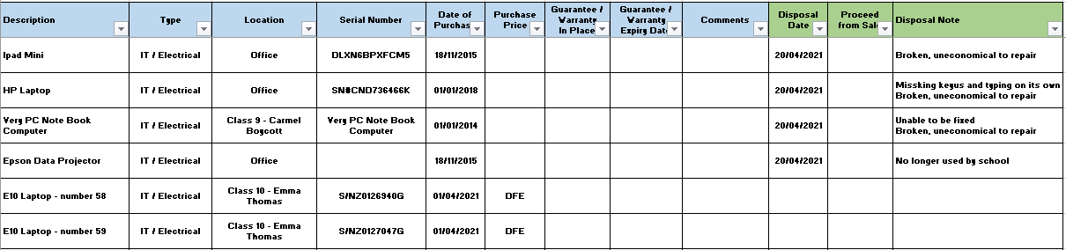

APPENDIX 2

Please complete for each safe
Location (full address with postcode)
Make
Model
Serial number
Contents including maximum value of cash at any one time
How often is the safe emptied?
Details of key procedures
Details of personnel with key access
Thank you for completing this form.
Please return via email to insurancesection@rochdale.gov.uk

