ST MARY’S RC  PRIMARY &NURSERY  SCHOOL | 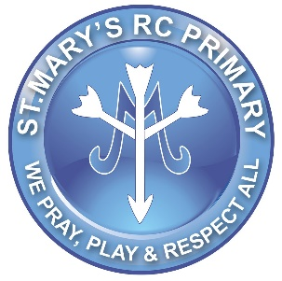
Discretionary Leave Request

Discretionary leave request must be in writing to the Headteacher or Deputy Headteacher.

Please complete the below and issue for consideration.

Name
Dated of Request
Start Date of Absence
End Date of Absence
Length of Absence

Nature of Leave Request

Following consideration the outcome of the request is that the application has been:-

Approved / Declined (delete as necessary)
If Declined, reasoning
Subject to Approval | Paid / Unpaid (delete as necessary)
Considered by | Mrs Geddis / Mr McGrail
Date

