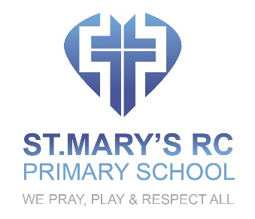

ENGLISH POLICY

OVERVIEW
This policy will ensure that, at St. Mary’s, we teach pupils to speak, read and write fluently so that they can communicate their ideas and emotions to others and, through their reading and listening, others can communicate with them. Developing pupils’ skills in reading will enable them to develop culturally, emotionally, intellectually, socially and spiritually and the literature we immerse children in will play a key role in such development.

INTENT
- To promote high standards of language and literacy, reading, spelling, writing, speaking and listening.
- To equip pupils with a strong command of the spoken and written word, and to develop their love of literature through widespread reading for enjoyment
- To teach pupils to read easily, fluently and with good understanding
- To help pupils develop the habit of reading widely and often, for both pleasure and information
- To ensure that pupils acquire a wide vocabulary, an understanding of grammar and knowledge of linguistic conventions for reading, writing and spoken language
- To help pupils to appreciate our rich and varied literary heritage
- To teach pupils to write clearly, accurately and coherently, adapting their language and style in and for a range of contexts, purposes and audiences
- To enable pupils to use discussion in order to learn; they should be able to elaborate and explain clearly their understanding and ideas
- To ensure that pupils are competent in the arts of speaking and listening, making formal presentations, demonstrating to others and participating in debate.

IMPLEMENTATION
- Teachers will develop pupils’ spoken language across the whole curriculum – cognitively, socially and linguistically.
- Spoken language will underpin the development of reading and writing.
- The quality and variety of language that pupils hear and speak will be used for developing their vocabulary and grammar and their understanding for reading and writing.
- Teachers will ensure the continual development of pupils’ confidence and competence in spoken language and listening skills.
- Pupils will develop a capacity to explain their understanding of books and other reading, and to prepare their ideas before they write.
- Pupils will be helped to make their thinking clear to themselves as well as to others and teachers will ensure that pupils build secure foundations by using discussion to probe and remedy their misconceptions.
- Drama, poetry and role play will be used to build pupils confidence and to practice their skills in speaking, listening reading writing and performing in front of others.
- The teaching of reading will focus on word reading and comprehension and it will be developed across the curriculum and phonics alongside other key strategies will play an important part in teaching pupils to read and spell.
- Comprehension skills will be developed through pupils’ experience of high-quality discussion with their teachers, as well as from reading and discussing a range of stories, poems and non-fiction.
- All pupils will be encouraged to read widely across both fiction and non-fiction to develop their knowledge of themselves and the world in which they live, to establish an appreciation and love of reading, and to gain knowledge across the curriculum
- Teaching will develop pupils’ competence in transcription and composition and they will be taught how to plan, revise and evaluate their writing.
- Pupils will be taught to use the elements of spelling, grammar, punctuation correctly and to understand and use Standard English in their speaking and writing

IMPACT
English is a very important subject taught in this school. All the skills of English are essential to participating fully as a member of society. Pupils, therefore, will learn to speak, read and write fluently and confidently.

Revised and adopted by the Governing Body

Date 1 September 2021
Review Date 1 September 2024

