FIRST AID POLICY
OVERVIEW
From time to time whilst children are in our care they will get injured or become unwell and they need first aid. Every member of staff is in ‘loco parentis’ and will act accordingly to offer the care and help that could reasonably be expected of a ‘caring parent’ in those circumstances. We have in school members of staff who have been trained in First Aid and so the help of one of these staff should be sought as soon as possible. First Aid equipment is available in school and it should be used in the child’s best interest and with great care. Where it is judged necessary the emergency service should be called or the child should be escorted to hospital. Parents should be kept fully informed whenever a child has received first aid.
INTENT
- To provide safe and appropriate care for children and staff if they are in need of first aid.
- To ensure that we have sufficient trained first aid staff available to care for children or adults if the need arises.
- To ensure that we have at least two members of staff with paediatric first aid training to be available for the care of EYFS pupils.
- To ensure that all staff knows what to do if a child needs first aid treatment and how they should respond in those circumstances.
- To ensure that any child with known severe allergic reactions (anaphylaxis) is recognised by staff and where they have an EpiPen, it is available and staff know how to use it in an emergency. ( see annex)
- To ensure that we have appropriate first aid kit easily available in school with portable kits to take when children go off site on visits etc.
- To ensure that members of staff are given training and that those with first aid certificates are kept up-to-date.
- To ensure that all staff know how to involve the emergency services if they are needed.
- To ensure that appropriate medical support/attention and treatment is given to children.
- To keep parents and carers fully informed and involved if their child has been given first aid treatment.
IMPLEMENTATION
- To seek qualified medical and emergency assistance quickly for all but minor injuries – using the ‘better safe than sorry’ principle and always erring on the cautious i.e. if there is any doubt – seek qualified medical/emergency service (999) support or arrange for the child to be escorted to the nearest casualty facility.
- If an injury is sustained whilst the child is on a visit or other off site activity the senior member of staff present must notify the school as soon as the child’s needs are met.
- To have members of staff who have undertaken appropriate first aid training available at all times on site and where possible, when children are on visits.
- To have appropriate first aid equipment available on site at all times.
- To have portable first aid kits to accompany them, when pupils are off site.
- To provide access to certified first aid training and updated first aid training for members of staff.
- To encourage staff to undertake first aid training.
- To have effective ‘quick contact arrangements’ to involve parents as early as possible if their child needs medical assessment/treatment.
- To notify parents that child has had accident as soon as possible in form of text message, if serious then a phone call.
- To also notify parents in writing, using the school accident report slip, of any injury that their child has suffered. This should be done on the same day that the injury was received.
- To enter the details of the accident/injury and the treatment given, in the school ‘accident report form’. (EYFS separate form – se below)
- To complete online RIDA form for injuries illnesses requiring outside medical treatment (e.g. hospital/GP)
- To ensure that first aid training is up to date and that staff attend approved courses.
- For children in EYFS, please see ‘EYFS Accident/Incident Reporting Procedure’.
IMPACT
Children and adults in this school will be kept safe but on the rare occasion when they need first aid treatment, the school will see that appropriate treatment is given by members of staff with appropriate levels of training and knowledge of first aid . Where medical and emergency treatment is needed, medical help will be sought quickly. All staff will carry out their duty of care professionally at all times and parents will be kept fully informed if their child has needed first aid treatment.

Anaphylaxis
Anaphylaxis is a serious life-threatening type of allergic reaction. It usually develops suddenly and gets worse very quickly.
The symptoms include:
- feeling lightheaded or faint
- breathing difficulties – such as fast, shallow breathing
- wheezing
- a fast heartbeat
- clammy skin
- confusion and anxiety
- collapsing or losing consciousness
There may also be other allergy symptoms, including an itchy, raised rash (hives), feeling or being sick, swelling (angioedema), or stomach pain.

What to do if someone has anaphylaxis
Anaphylaxis is a medical emergency. It can be very serious if not treated quickly.
If someone has symptoms of anaphylaxis, you should:
- call 999 for an ambulance immediately – mention that you think the person has anaphylaxis
- remove any trigger if possible – for example, carefully remove any wasp or bee sting stuck in the skin
- lie the person down flat – unless they're unconscious, pregnant or having breathing difficulties
- use an adrenaline auto-injector if the person has one – but make sure you know how to use it correctly first
- give another injection after 5-15 minutes if the symptoms don't improve and a second auto-injector is available
- Keep the child lying down or seated and have someone stay with them until they have been assessed by a paramedic.
- Unconscious patients should be placed in the recovery position

Guide to Using An EpiPen®
- There is no need to remove clothing to use an EpiPen®, but make sure the orange end will not hit buckles, zips, buttons or thick seams on clothes.
- To remove EpiPen® from the carry case. Flip open the lid on the carry case. Tip the carry case and slide the EpiPen® out of the carry case.
- Lie the child down with their legs slightly elevated to keep their blood flowing or sit them up if breathing is difficult.

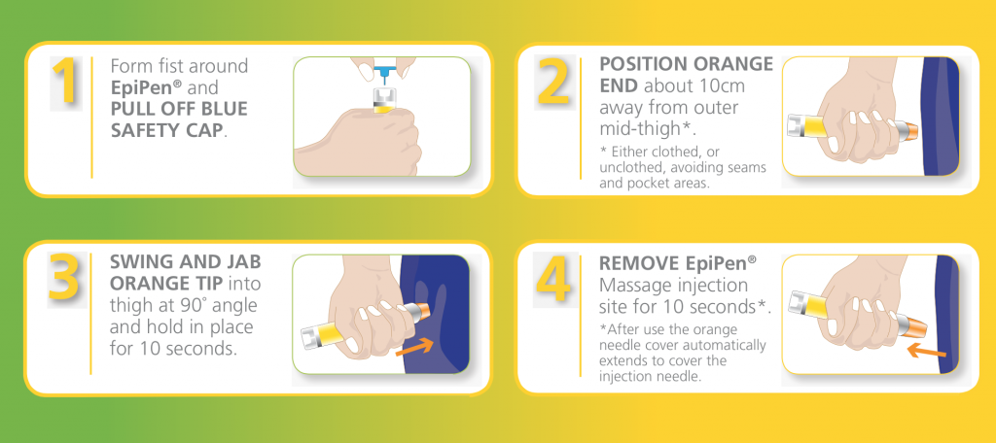
Each EpiPen® can only be used once. If symptoms don’t improve, you can administer a second EpiPen® after 5-15 minutes.
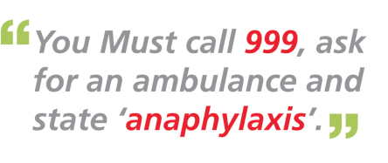

Revised and adopted by the Governing Body

Date 1 September 2021
Review Date 1 September 2024

