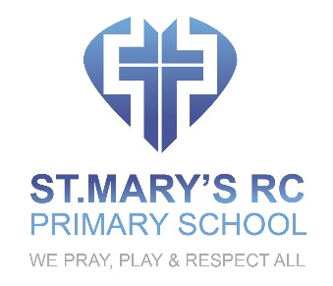

HEALTH AND SAFETY POLICY

OVERVIEW
The health and safety of the children, staff and other users of St. Mary’s R.C. Primary school will have the highest importance for everyone working in this school. Everything will be done to promote good health and to keep all safe and to protect them from danger. PLEASE ALSO SEE COVID SCHOOL OPENING PLAN (RISK ASSESSMENT)

INTENT
- To keep all safe and healthy
- To establish excellent and effective procedures for keeping children safe, healthy and active.
- To put into place safe procedures and contingency plans for the health and safety of learners.
- To ensure that staff are trained and carry out their health and safety responsibilities well.
- To ensure that there is a quick and effective response to any incident.
- To ensure that any probable sources of danger are identified and that appropriate action is taken.
- To ensure that appropriately trained members of staff provide first aid in case of accident.
- To ensure that the school makes effective use of various outside agencies when appropriate.
- To use the curriculum and extra curricular activities to promote children’s healthy growth and Physical development

IMPLEMENTATION
- All staff will follow the health and safety procedures that have been established and put into place.
- Risk assessments will be carried out by staff before activities and visits.
- Regular health and safety checks will be carried out to check the school environment and equipment.
- Detailed records of accidents and incidents will be recorded and kept.
- All will promote healthy eating and drinking and care will be taken to ensure that pupils’ food allergies are taken into account when they are in contact with food and ingredients.
- Play, physical education, sport, games and extra-curricular education will promote children’s physical growth and development. Children will be encouraged to be active and healthy.
- Science and Personal and Social Education will be used to teach children about healthy eating and healthy lifestyles.

IMPACT
This school will do all it can to provide a safe environment in which children can work, learn and play. Through the curriculum and other activities it will do all it can to facilitate the healthy growth and development of learners. This policy should be read in conjunction with all other safeguarding and child protection policies.

Revised and adopted by the Governing Body

Date 1 September 2021
Review Date 1 September 2024

