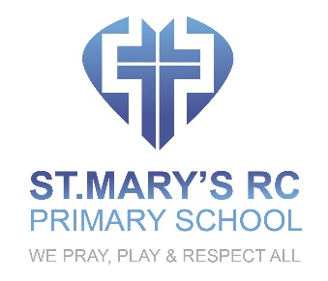

MUSIC POLICY

OVERVIEW
In St. Mary’s RC School, all children will have the opportunity to sing, to listen to music, to experience different musical instruments, to perform and to enjoy music. Music is a universal language that embodies one of the highest forms of creativity. As pupils progress, they will develop a critical engagement with music, allowing them to compose, and listen to a wide range of music from their own cultural heritage and from other cultures.

INTENT

In order to give music a higher status within the curriculum, we encourage children to participate in a variety of musical activities through which, along with an understanding of the inter-related dimensions of music, we aim to develop: good listening skills; self-confidence and self-esteem; teamwork; memory; creativity; resilience and perseverance.

- The programmes of study of the National Curriculum for music will underpin teaching and learning:
- Children will perform, listen to, review and evaluate music across a range of historical periods, genres, styles, cultures and traditions, including the works of the great composers and other musicians including contemporary musicians.
- Children will learn to sing and to use their voices, to create and compose music on their own and with others, have the opportunity to learn a musical instrument, use technology appropriately and have the opportunity to progress to the next level of musical excellence
- Pupils will be taught to use their voices expressively and creatively by singing songs and speaking chants and rhymes
- All will understand and explore how music is created, produced and communicated, including through the inter-related dimensions: pitch, duration, dynamics, tempo, timbre, texture, structure and appropriate musical notations.

IMPLEMENTATION
- Pupils will learn how to play tuned and untuned instruments musically play and perform in solo and ensemble contexts, using their voices and playing musical instruments with increasing accuracy, fluency, control and expression
- Pupils will experiment with, create, select and combine sounds using the inter-related dimensions of music. improvise and compose music for a range of purposes using the inter-related dimensions of music
- Children will learn how to listen with concentration and understanding to a range of high-quality live and recorded music.
- Pupils will learn how to pay attention to detail and recall sounds with increasing aural memory.
- When appropriate they will use and understand staff and other musical notations
- They will be helped to appreciate and understand a wide range of high-quality live and recorded music drawn from different traditions and from great composers and musicians as they develop an understanding of the history of music.

IMPACT
All pupils will benefit from a high quality music education which will engage and inspire pupils to develop a love of music and their talent as musicians. It will increase their self-confidence, creativity and sense of achievement. As pupils progress, they will develop a critical engagement with music, allowing them to listen to and enjoy a wide and rich range of music.

Revised and adopted by the Governing Body

Date 1 September 2021
Review Date 1 September 2024

