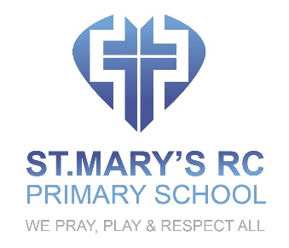

PHYSICAL EDUCATION POLICY

OVERVIEW
All pupils will benefit from a physical education curriculum which motivates them to succeed and participate in sport, games, exercise and other physically-demanding activities. It will offer good and appropriate opportunities for pupils to develop a wide range of physical skills, knowledge and understanding to promote their health and fitness. Through physical education they will have opportunities to compete in sports, games and other activities which build their character and help to embed values and qualities such as determination, endurance, perseverance, fairness and respect.

INTENT
- To help children become physically active and to help them understand the importance of physical activity in promoting a healthy active life.
- To teach children about safety when they are near water
- To help children develop appropriate skills as they participate in a broad range of physical activities
- To give children the opportunities to enjoy and engage in competitive sports, games and other co-operative physical activities, in a range of increasingly challenging situations.
- To help children develop fundamental movement skills, become increasingly competent and confident and access a broad range of opportunities to extend their agility, balance and coordination, individually and with others.
- To teach all children to swim and to life save.

IMPLEMENTATION
- We will use the national curriculum for physical education to underpin our teaching and learning
- We will teach children how to master basic movements including running, jumping, throwing and catching, as well as developing balance, agility and co-ordination, and begin to apply these in a range of activities
- We will provide opportunities for children to participate in team games and competitive games which will be modified where appropriate [for example, badminton, basketball, cricket, football, hockey, netball, rounders and tennis], and apply basic principles suitable for attacking and defending
- We will provide opportunities for children to enjoy modern educational dance and to perform dances using simple movement patterns.
- Pupils will be taught to apply and develop a broad range of skills, learning how to use them in different ways and to link them to make actions and sequences of movement.
- Appropriate physical activities will be used develop flexibility, strength, technique, control and balance through athletics and gymnastics
- Children will take part in appropriate outdoor and adventurous activity challenges both individually and within a team
- Pupils will be encouraged to compare their performances with previous ones and demonstrate improvement to achieve their personal best
- Before they leave school they will be taught to swim competently, confidently and proficiently over a distance of at least 25 metres using a range of strokes
- Pupils will be taught to perform safe self-rescue in different water-based situations.

IMPACT
Through our physical education curriculum pupils will develop an understanding of how to develop and improve their knowledge, skills and understanding of physical education in different physical activities and sports and learn how to evaluate and recognise their own success. They will enjoy communicating, collaborating and competing with each other as they exercise their bodies and build their skills.

Revised and adopted by the Governing Body

Date 1 September 2021
Review Date 1 September 2024

