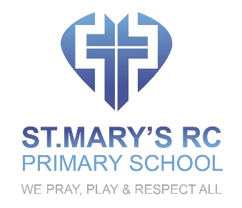

POLICY FOR SUPPORTING PUPILS AT SCHOOL WITH MEDICAL CONDITIONS

OVERVIEW
When supporting pupils with identified medical conditions, St. Mary’s will follow the statutory DfE Guidance for Supporting Pupils with Identified medical Conditions (governing bodies of maintained schools and proprietors of academies in England) issued in December 2015. We will ensure that all children with medical conditions, in terms of both physical and mental health, are properly supported in school so that they can play a full and active role in school life, remain healthy, achieve and make good academic progress.

INTENT
- To recognise that pupils with long-term and complex medical conditions may require ongoing support, medicines or care while at school to help them manage their condition and keep them well.
- To provide effective support for each child’s individual medical condition and to ensure that all pupils including children with medical conditions feel safe.
- To ensure that in addition to the educational impacts, any social and emotional implications associated with medical conditions are provided for effectively and sensitively.

IMPLEMENTATION
- To ensure that this policy is implemented effectively we will follow the statutory guidance for governing bodies of maintained schools and proprietors of academies in England
Issued in December 2015
- We will establish relationships with relevant local health services to receive and fully consider advice from healthcare professionals and listen to and value the views of parents and pupils when agreeing the appropriate levels of support.
- The SENCO will be given overall responsibility for policy implementation.
- Sufficient staff will suitably trained and all relevant staff will be made aware of the child’s condition. Appropriate training will be commissioned from the LA and any other approved provider.
- Effective cover arrangements in case of staff absence or staff turnover, will ensure that someone is always available and any supply teachers will be briefed and given all relevant support.
- The headteacher will contact the school nursing service in the case of any child who has a medical condition that may require support at school, but who has not yet been brought to the attention of the school nurse.
- Risk assessments for school visits, holidays, and other school activities outside the normal timetable will take full account of children with medical conditions
- Individual healthcare plans will agreed and will be carefully monitored by the SENCO and they will be reviewed and developed to take account of any changing needs
- Parents of children with medical conditions will be fully involved and consulted at every stage of the pupil’s attendance at this school including at the initial admission process.
- We will work with parents, medical and support staff to put into place effective strategies monitoring and interventions in emergency circumstances.
- This strategy will allow for the fact that children’s health needs may change over time, in ways that cannot always be predicted, sometimes resulting in extended absences.
- Where after medical treatment, a pupil needs to reintegrate back into school it will be properly supported so that all children with medical conditions fully engage with learning and do not fall behind when they are unable to attend.
- After discussion with parents, children who are competent will be encouraged to take responsibility for managing their own medicines and procedures with an appropriate level of supervision. This will be reflected within individual healthcare plans
- The healthcare plan, will clearly define what constitutes an emergency and explain what to do. All relevant members of staff will be made aware of emergency symptoms and procedures.

IMPACT
Pupils at this school with medical conditions will be supported appropriately according to their individual needs, so that they have full access to the education we offer, including school trips and physical education. They will thrive and do well in our supportive and caring ethos. They will be given the opportunity to make friends and be fully integrated and valued members of our school community.

Revised and adopted by the Governing Body

Date 1 September 2021
Review Date 1 September 2024

