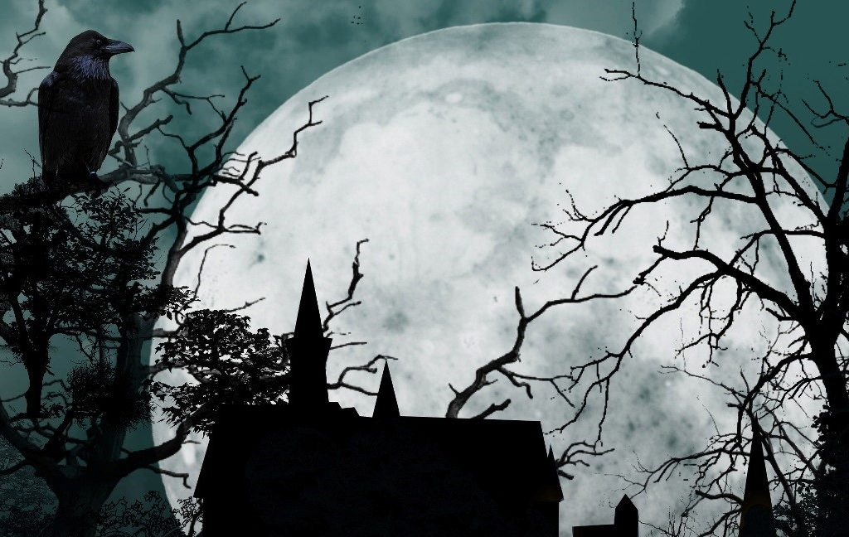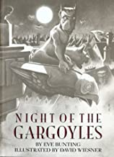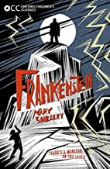

The children will continue to think about healthy lifestyles and the effects exercise has on the body. They will be learning team sports including basketball and tag rugby.

RE Come and See

Sources – The Bible

• A wide variety of books and the purpose for which they were written – Explore

• The Bible as the story of God’s love, told by the People of God – Reveal

Acquire the skills of assimilation, celebration and application of the above – Respond

**RSE – Life to the Full Programme.**

In English we will be focusing on:

Reading – comprehension skills, inference, retrieval and vocabulary. the children will work on these skills through shared, guided and independent reading activities.

Writing – sentence structure and sentence types (year 5 and 6 expectations).

The children will use high quality texts to write descriptions, narratives, poetry and arguments – thinking about the purpose and audience.

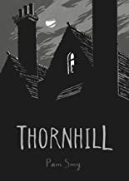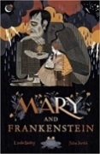

Computing:

The children will be focussing on internet safety and coding building on previous skills and knowledge.

**Year 6**

**Matter of Life or Death Spring 1**

Topic

Ancient Islamic Civilisation

The children will learn about why Baghdad was such an important city in the Islamic Empire and locate this on a series of modern and historical maps. The will learn about:

Caliphs and the House of Wisdom.

How the work of early Islamic doctors has influenced modern medicine.

Describe why from the 8th Century onwards, Islamic history became known as The Golden Age of Islam.

Learn about key historical figures during this period.

In Maths we will be focusing on:

The 4 operations (addition, subtraction, multiplication, division).

Decimals and percentages and algebra.

The children will complete daily fluent in 5 and flashback 4 activities alongside guided practice work. They will access maths whizz and ttrs.