**ST.MARY’S RC**



### PRIMARY SCHOOL

WE PRAY, PLAY & RESPECT ALL

Dear Parent/Carer,

This letter is to remind all pupils and parents/carers of the PE kit policy at St Mary’s RC Primary. The purpose of the policy is to keep our pupils safe during lessons and dressed in appropriate clothing for exercise. We have had an influx this year of pupils wearing inappropriate clothing, which is too revealing and not indicative of our Catholic ethos. Please note that football kits are not permitted and that our school PE kit is part of our school uniform. We insist that all pupils wear full PE kit to all PE lessons in school.

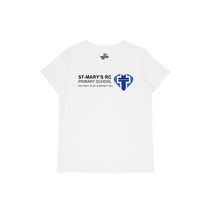PE Kit options:

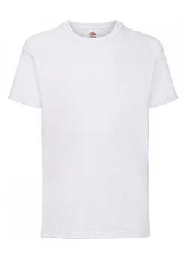White t-shirt (either with the school logo or plain).

Please note that crop tops/bra tops are not permitted, regardless of the weather, unless covered by a white t-shirt.

Black shorts or cycling shorts (knee length only and not short gym shorts).

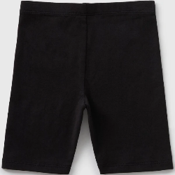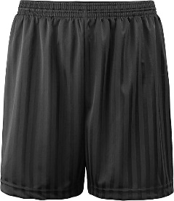

Pupils can wear black tracksuit bottoms / black sports leggings (not see through) should they wish for the colder months.

Rules of participation:

✓ Trainers or pumps must be always brought to school for PE lessons to allow staff to plan for all weather conditions. ✓ Long hair must be tied back. ✓ No jewellery should be worn in PE lessons. ✓ No watches to be worn in PE lessons for safety reasons.

If you have any questions regarding the PE kit, please feel free to get in touch. All kit can be bought relatively cheaply from all major supermarkets. Should you wish to purchase the school PE t-shirt, it is available at Broadbents at a cost of £6.

Yours sincerely

S Bollado

Headteacher



St. Mary’s RC Primary School Wood St, Langley. Middleton

M24 5GL

0161 643 7594

[www.stmrc.co.uk](http://www.stmrc.co.uk/)

office@st-mrc.co.uk

#### Headteacher

Mrs. S. Bollado